


General Practice Workforce Data Collection
Declaration Form – Completion Guide

Introduction
This section of the workforce survey is directly linked to new investment in general practice. The information you provide is vital to demonstrating how this funding is being used to expand the workforce at practice level and helps build a strong case for continued and future investment in general practice. The data collected will be used by PSDS and the Scottish Government to understand the additional workforce capacity created as a direct result of this funding. Health Boards will also use this information to support their role in verifying that intentions to expand workforce capacity are commensurate with the funding provided, and that these intentions have been delivered by practices.
This guidance has been developed by the Scottish Practice Management Development Network (SPMDN) to support completion of the declaration form. It has been reviewed with colleagues in the Scottish Government and Public Service Delivery Scotland (formerly NSS) to ensure it aligns with the policy intent and the requirements of the national data collection.

Supporting resource: Mock Data Collection Form
To support practices in preparing for the workforce survey, a mock GP Workforce Data Collection Declaration Form has been developed. It is designed as a blank practice training tool to help practices prepare figures before entering the oﬀicial online form.
The mock form mirrors the visible structure of the declaration form screenshots provided for Part 1 and Part 2. It does not send information to NHS National Services Scotland, the Health Board or any other service. It is for preparation only.
The mock form has been developed to help practices:
- understand what information is likely to be needed before opening the oﬀicial
app
- prepare and sense-check figures in advance, including sessions, hours, posts and costs
- reduce errors when completing the live form by working through the structure beforehand
- save or print a local copy for checking and internal discussion
In the mock version, users can enter values in the visible fields, view automatic totals where included, save progress in their own browser, print or save as PDF, and export a CSV record of values entered.

Because the mock form stores entries only in the user’s own browser, it is not a shared live form and does not submit or share data.
Important: the mock form does not replace the oﬀicial app. Final submission must
still be completed through the live GP Workforce Data Collection App.
Download the mock GP Workforce Data Collection Declaration Form. Please click the SharePoint link, select Download, then open the downloaded file in Chrome or Edge. Please do not complete the form in the SharePoint preview, as some interactive features may not work properly there.
If you have problems accessing this SharePoint file, please contact
practicemanager@nes.scot.nhs.uk for a copy.

Before you start
Before beginning the data collection app, you may want to gather the following information:
- progress in expanding the practice workforce using the Workforce Payment issued in September/October 2025
- agreed plans for using the additional workforce funding to expand and/or redesign the practice workforce
- intentions for funding freed up in the Global Sum as a result of expenses investment
- contract details for all staﬀ employed during the reporting period,
including start and leaving dates
- dates of birth for all staﬀ members
- NMC or GMC numbers where relevant
- sickness and other absence information
- vacancy information for the reporting period
- details of locum or sessional GP cover

Core rules that apply throughout

Units of measurement
Doctor time must be recorded in sessions and non-doctor time must be recorded in
hours across all sections of the survey.

Scope of this guidance
The GP Workforce Data Collection includes several sections within the app, including
practice information, staﬀ data, vacancies, absences and final submission.

This guide focuses only on how to complete the Declaration Form sections (Part 1 and Part 2).
It does not provide detailed instructions for:
    - Practice Information
    - Staﬀ Information
    - Vacancies
    - Absences
    - Final submission
These are covered in the GP Workforce Data Collection Guidance 2026

What each declaration section covers
    - Part 1 asks about how the practice used the 2025/26 Workforce Payment.
    - Part 2 asks about how the practice intends to use additional funding for 2026/27, including workforce and expenses funding.

Key definitions used in the workforce survey

Sessions
A session is the unit used to record GP time. Practices should enter the number of GP sessions per week. The Practice Information section asks each practice to confirm how long a session is at that practice. The GP Workforce Data Collection Guidance 2026 notes that the current BMA standard for a salaried GP session is 4 hours 10 minutes.

Hours
Non-GP staﬀ time must be recorded in hours per week.

Retained capacity
Retained capacity means sessions or hours that the practice had expected to reduce, but was able to keep because of funding. This applies to GP sessions and non-GP hours.

Increased capacity of existing staﬀ
This means additional sessions or hours provided by existing staﬀ who increased their work commitment using the funding. This includes permanent increases and temporary increases funded through the payment.

Newly recruited posts
These are posts the practice has been able to recruit to using the relevant funding. The form then asks for the total weekly sessions or hours represented by those posts.

Temporary cover
Temporary cover means cover for holiday, sickness leave, parental leave or other absence. It does not include cover for vacant posts.

Internal locum
An internal locum is a GP already working within the practice who works an additional session to cover an absence.

External locum
An external locum is a GP who does not already work in the practice and is employed specifically to cover an absence.

Vacancy
For the purpose of this collection, a vacancy is an established, funded post within a practice that is currently unfilled and is actively being recruited to. It does not include posts currently being filled by locums.

Absence categories
Absences should be split into:
    - total sick leave, including paid and unpaid
    - maternity, paternity or adoption leave
    - parental leave
    - special leave

Annual leave and public holidays should not be included.

Staﬀ included in the return
Include all staﬀ employed in a substantive post across all staﬀ groups, including partners. Include staﬀ on sabbatical, sick leave, maternity leave, paternity leave, parental leave, adoption leave or other leave. GP trainees should not be recorded in the app because this information is held by PSD Scotland (formerly NES). Attached staﬀ employed by the Health Board and/or the HSCP should not be recorded.

How to report costs correctly
- in Part 1, report the actual spend incurred within the reporting period
- in Part 2, report the planned investment linked to the intended increase in capacity

Part 1 – actual spend
If a staﬀ member started part-way through the reporting period enter the cost actually incurred during the period they worked. If an existing staﬀ member increased sessions or hours mid-year, enter the actual additional spend for that period.

Part 2 – planned spend
Part 2 is about intentions for 2026/27. The form asks practices to set out plans to increase capacity over Tranche 1 and Tranche 2 funding. Practices should enter the planned investment associated with those intentions and this should be the full-year value.

What should be included in staﬀ costs?
When completing the investment (£) fields in the declaration form, costs should reflect the actual employer cost (including Employer NI and Pension contributions), not just basic salary. Associated costs such as advertising should not be included.
Practices may use the additional funding to support visa sponsorship costs for the practice such as the sponsor licence fee, Certificate of Sponsorship and/or the Immigration Skills Charge. Support for GP practices wishing to become a visa-sponsoring employer is available through NHS Education for Scotland (NES)’s GP Practice Visa Sponsorship Guide, which also links to further practical guidance, including the Scottish Government’s Guide for General Practices in Scotland on becoming a sponsor.

How do I calculate costs?
To estimate the cost of possible workforce options, practices should use the best available local information. This may include current payroll records, employment contracts, agreed salary or sessional rates, recent recruitment costs, locum invoices etc.
Workforce Capacity Guidance for General Practice – Annex B: Intentions to Increase Capacity and Annex C: Issuing Tranche 2 provides information on salaried GP pay ranges, Agenda for Change staﬀ costs and how to calculate the cost of a GP partner. Practices can use this guidance, alongside local cost information, to estimate the cost of possible workforce options when setting out their intentions.
Boards will use their own intelligence on the local costs of staﬀ to verify practice level intentions and provide assurance to the Scottish Government that these intentions are broadly in line with local market rates.

Declaration Form Part 1

2025/26 Workforce Payment – what the practice has done
The declaration form Part 1 relates to the Workforce Payment allocated to practices in 2025/26 and asks how the practice has used that funding to retain existing staff or expand the workforce.

Allocation
You can find details of your practice’s allocation of the Workforce Payment in Annex B – Practice Allocations of Susan Gallacher’s letter to Health Boards dated 14th May.

GP section
For GP staff, enter the following:
    - number of sessions per week retained that would otherwise have been reduced
    - number of new sessions per week provided by increasing the capacity of existing GPs
    - number of additional locum sessions provided per week that were only possible because of the funding - Only include locum work that increased capacity, not routine cover
    - number of newly recruited posts
    - number of new sessions provided by newly recruited posts

    - total investment (£) spent from the Workforce Payment to increase GP staﬀing
capacity

Non-GP section
For non-GP staff, enter the following in hours per week:
    - hours retained that would otherwise have been reduced
    - additional hours provided by increasing capacity of existing staﬀ
    - number of newly recruited posts
    - number of new hours provided by newly recruited posts
    - total investment (£) spent on increasing non-GP staﬀing capacity. The total investment (£) sum entered should not exceed your practice’s allocation of the 2025/26 £15m Workforce Payment.

Declaration Form Part 2

2026/27 plans and intentions
Part 2 asks practices how they intend to use additional funding for workforce and expenses in 2026/27. This section is split into two parts:
    - Section 1 – freed-up Global Sum from expenses investment
    - Section 2 – workforce expansion plans

Allocations
You can find details of your practice’s allocation of the Expenses Reimbursement and Workforce Funding Tranche 1 and Workforce Funding Tranche 2 in Annex B – Practice Allocations of Susan Gallacher’s letter to Health Boards dated 14th May.

Section 1 – freed-up Global Sum from expenses investment
This section asks whether the practice intends to use funding freed up in the Global Sum as a result of the expenses investment to:
    - increase workforce capacity only
    - address other sustainability pressures only
    - or both
If the practice selects “increase workforce capacity only” or “both”, you should include the amount you intend to use based on details of your practice expenses allocation only – do not include workforce funding. This should be included in the “Please specify the cash sum your practice intends to invest in expanding the workforce” box. The amount entered should not exceed your practice's allocation of the £4 million Expenses Reimbursement.
If the practice selects “address other sustainability pressures only” or “both”, the form asks for a brief description of the sustainability pressure(s) to be addressed. Other sustainability pressures that can be addressed with this funding include:
    - Training opportunities to expand practice staﬀ skill set
    - Addressing any of the following non-staff cost pressures facing the practice, particularly any costs that have increased beyond inflation:
      - Cleaning expenses
      - Clinical and professional indemnity
      - Equipment repairs and maintenance
      - Heat, light and power (energy costs)
      - Insurance, including building and contents and public liability
      - Medical supplies
      - Non-clinical waste removal
      - Premises maintenance and repairs
      - Postage, printing and stationery
      - Rates and water
      - Telephony costs
    - Premises costs not covered by existing reimbursements, for example building insurance costs, internal and external repairs, plant, building and grounds maintenance costs, non-clinical waste removal in areas this is not already reimbursed
    - Premises improvements to enable increased capacity, improved patient access or experience
    - Purchasing products and services that could improve practice eﬀiciency and directly support patient experience, for example accessibility improvements, information screens or ways of checking metrics in waiting rooms (PODS). Practices should consult with their Board’s Digital Directorate before doing so.
Any reduced outgoings as a result of the expenses investment must be recycled by practices to increase workforce capacity or address other sustainability pressures.

Expenses vs Tranches
The expenses fund is a separate fixed allocation (not part of Tranche 1 or Tranche 2) – track plans for it in Part 2 Section 1. Only record plans for Tranche 1 and Tranche 2 workforce funding in Part 2 Section 2.

Section 2 – workforce expansion plans
This section asks the practice to set out plans to increase current capacity over two tranches of funding in 2026/27. If you are not planning to use the money for one method of increasing staﬀ capacity, those parts can be left blank.

Intention Timeframes
    - Tranche 1 increases = expected capacity by 30 September 2026 (mid-year);
    - Tranche 2 increases = expected capacity by 31 March 2027 (year-end).
Tranche 2 is intended to represent a further increase in capacity beyond that delivered through Tranche 1, unless both tranches are being used together to support a single increase.
Only record the capacity increase you plan to achieve by those deadlines with each tranche’s funding. Tranche 2 funding is conditional on meeting Tranche 1 goals by 30 September 2026.

Rural flexibility
Practices are expected to deliver Tranche 1 intentions by 30 September 2026. For smaller or more remote practices where recruitment may be more challenging, Health Boards may apply discretion in interpreting the delivery and timing, in line with the relevant guidance. Boards should provide this flexibility where practices receive less than £20,000 tranche 1 funding and are situated in areas categorised as classes 4-8 using the Scottish Government’s 8-fold rural / urban classification. More details are included in Workforce Capacity Guidance for General Practice – Annex B: Intentions to Increase Capacity and Annex C: Issuing Tranche 2

GP workforce
For GP staﬀ, the form asks about:
    - intended increases to the capacity of existing GPs, in sessions per week
    - intended increases by recruiting or employing new GPs, in sessions per week
    - intention to change current salaried GPs into partner GPs, in sessions per week
    - associated investment values for partners, salaried GPs and locums (full year costs should be reported)
    - numbers of additional GP posts already in place, currently being advertised, or recruited to but not yet in post prior to 31st March 2026

Non-GP workforce
For non-GP staﬀ, the form asks for each relevant role:
    - intended increase to existing staﬀ, with investment and hours
    - intended number of newly recruited staﬀ, with investment (full year costs should be reported), posts and hours
    - whether any of these posts are already in place, being advertised, or recruited to but not yet in post prior to 31st March 2026

Investment costs
Practices should enter the intended investment linked to their workforce expansion plans. This should be reported as the full year value, based on the annual cost of the role, as if the increase in capacity were in place for a full 12 month period. This should not be based on the cost incurred during the reporting period or the length of time the staﬀ member is in post. Practices should enter the full annual cost of the workforce increase (including on costs) linked to their planned increase in capacity. This should be recorded even where the total annual cost exceeds the value of the workforce funding allocation.
Scenario 1 – The practice has a Tranche 1 allocation of £45,000 and a Tranche 2 allocation of £19,000. In Tranche 1, the practice plans to increase capacity by recruiting a new salaried GP for 2 sessions per week. The annual cost to the practice is £19,000 per session. The practice also plans to increase the hours of an existing receptionist by 6 hours per week, at an annual cost of £7,140. In Tranche 2, the practice plans to increase the sessions of an existing salaried GP from 5 to 6 sessions per week. This should be recorded in the declaration form as follows:
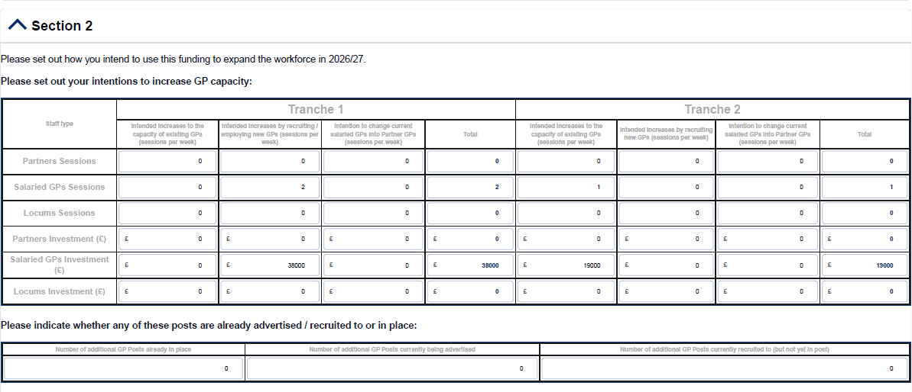
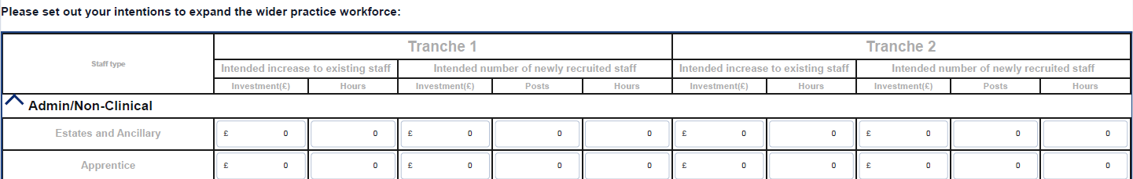
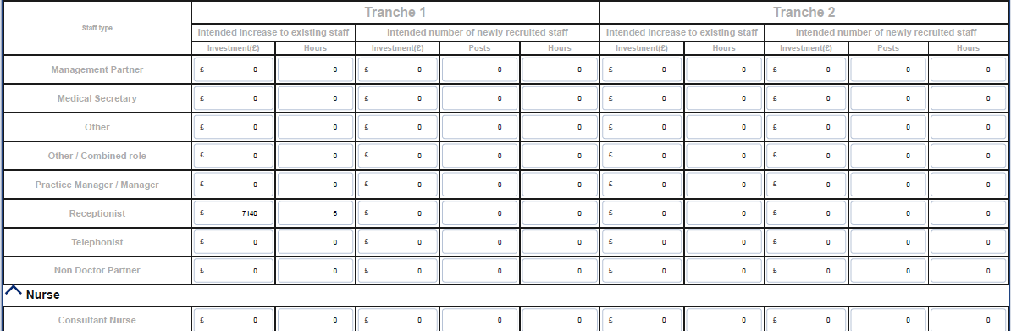

If costs change, for example after recruitment negotiations, the practice can adjust it’s intentions in later quarterly surveys.

Single Post, Both Tranches

Please note that this section updates guidance on recording costs for tranche 1 and tranche 2 in the Q&A document issued on 8 June.
If the practice funds one post across Tranche 1 and Tranche 2, you should attribute capacity increase full year costs to Tranche 1. If there will be no further increase to capacity with Tranche 2 (i.e. additional posts/ increase to existing posts), then record zero increase for both capacity and for investment cost for Tranche 2 and notify your Health Board lead (Appendix 1) of the plan.
Scenario 2 – The practice has a Tranche 1 allocation of £45,000 and a Tranche 2 allocation of £19,000. The practice plans to increase capacity by recruiting a new salaried GP in April for 4 sessions per week. The annual cost to the practice is £19,000 per session. This post will be funded across Tranche 1 and Tranche 2. This should be recorded in the declaration form as follows and the practice should send an email to their Health Board lead (appendix 1) to explain why they have recorded a ‘0’ for Tranche 2.
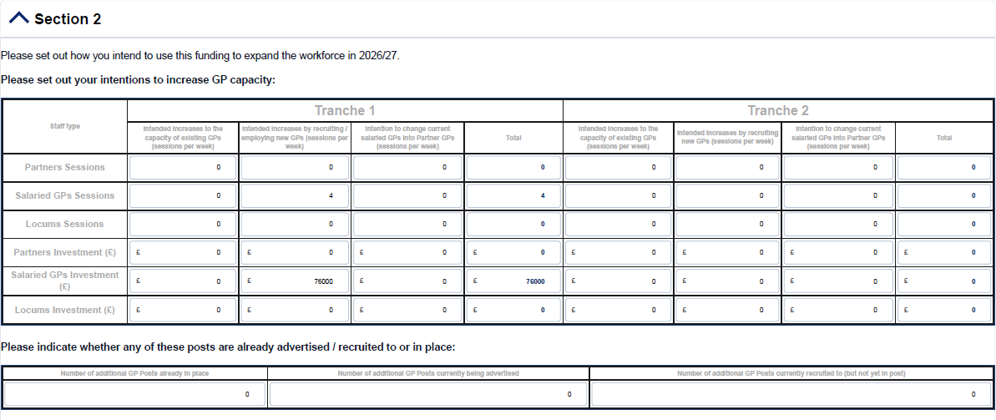

Flexible Updates
The practice can adjust intentions in later quarterly surveys if plans change (e.g. if recruitment is delayed and other plans are put in place to use the funding).

Posts recruited to prior to 31st March 2026
If you recruited GPs or staﬀ before 31 Mar 2026 with the intention of using the new funding, include them in Section 2 (the second table for each workforce group) so they’re counted as funded expansions rather than baseline staﬀ. There is no strict timescale in the guidance, the key point is that these posts should represent intended expansion supported by the new funding.

Please note that when completing the GP workforce table it does not have prior to 31st March 2026 included in the table description, the non-GP workforce table does.
Completing these tables ensures your baseline reflects the original capacity without new funded roles (otherwise you’d undercount your increase).
Scenario 3 – The practice has a Tranche 1 allocation of £45,000 and a Tranche 2 allocation of £19,000. In Tranche 1, the practice plans to increase capacity by recruiting a new salaried GP for 3 sessions per week. The annual cost to the practice is £19,000 per session. When recruiting the practice planned to use 2026/2027 workforce funding and a GP was recruited and started work in February 2026. In Tranche 2, the practice plans to increase the sessions of an existing salaried GP from 5 to 6 sessions per week. This should be recorded in the declaration form as follows:
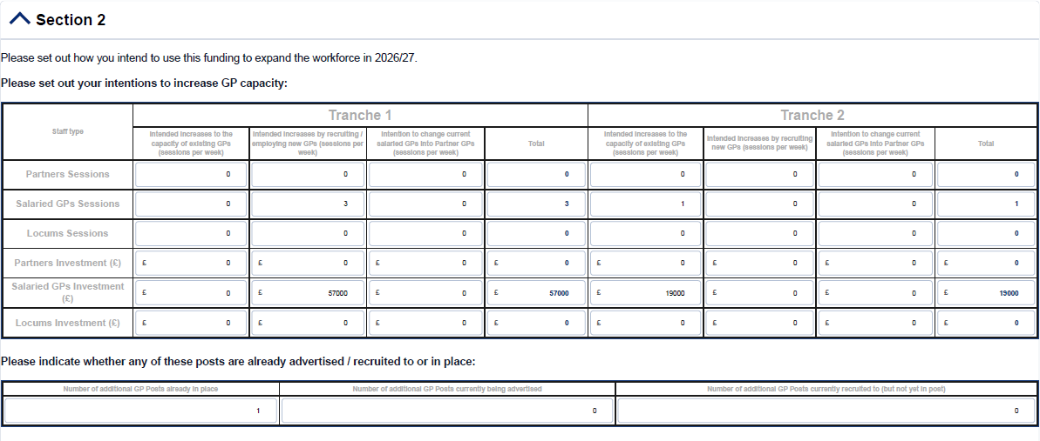

Accessing the app and support

Accessing the app
Use the oﬀicial link:

Open GP Workforce Data Collection App
Check:
    - Your username
    - Your GP practice code
    - You are using the latest version of the app

Guidance
GP Workforce Survey Guidance 2026 Workforce Survey Declaration Form - Q&A

Technical support
Contact: NSS.GPDataCollection@nhs.scot

Declaration Form Completion support
For guidance queries contact: practicemanager@nes.scot.nhs.uk
They can help with:
    - interpreting questions
    - confirming what data to include
    - resolving practice-specific queries

Final checks before submission
Before submitting:

Check 1: Data consistency
- Sessions vs hours correct
- Costs align with activity
- No duplication across categories

Check 2: Financial accuracy
- Part 1 totals match actual spend
- Part 2 totals reflect the full annual cost of your workforce increase

Check 3: Logical alignment
- Workforce increase matches funding
- Recruitment data reflects plans

Appendix 1 – NHS Board contacts

Health Board | Contact | Email address
NHS Ayrshire and Arran | Debbie McGill | debbie.mcgill@aapct.scot.nhs.uk
NHS Borders | Holly Hamilton-Glover | Holly.HamiltonGlover@nhs.scot
NHS Dumfries and Galloway | Linda Bunney | Linda.Bunney@nhs.scot;
NHS Fife | Nicola Taylor | Nicola.Taylor3@nhs.scot
NHS Forth Valley | Louise McCallum | louise.mccallum12@nhs.scot
NHS Grampian | Peter MacLean | peter.maclean@nhs.scot
NHS Greater Glasgow and Clyde | Gary Dover | Gary.Dover@nhs.scot
NHS Highland | Andy Ireland | Andy.Ireland@nhs.scot
NHS Lanarkshire | Alistair MacKintosh | alistair.mackintosh@lanarkshire.scot.nhs.uk
NHS Lothian |  | loth.gmscontract@nhs.scot
NHS Orkney | John Daniels | john.daniels@nhs.scot
NHS Shetland | Lisa Watt | Lisa.Watt@nhs.scot
NHS Tayside | Rachel Bennison | Rachel.Bennison@nhs.scot
NHS Western Isles | Michelle Taylor | michelle.taylor44@nhs.scot



PSD Scotland Gyle Square
1 South Gyle Crescent Edinburgh
EH12 9EB
Tel: 0131 275 6000

www.publicservicesdelivery.scot

Public Services Delivery Scotland

