HEALTH AND CARE (STAFFING) (SCOTLAND) ACT 2019 – NHS NATIONAL SERVICES SCOTLAND ANNUAL REPORT 2025/2026

GUIDANCE ON USING THIS TEMPLATE 2
Summary Section 2
Individual duties / requirements 3
Summary 5
Duty 12IA: Duty to ensure appropriate staffing 18
Duty 12IC: Duty to have real-time staffing assessment in place. 30
Duty 12ID: Duty to Have Risk Escalation Process in Place. 36
Duty 12IE: Duty to have arrangements to address severe and recurrent risks. 41
Duty 12IF: Duty to Seek Clinical Advice on Staffing. 48
Duty 12IH: Duty to ensure adequate time given to clinical leaders. 53
Duty 12II: Duty to ensure appropriate staffing: training of staff. 58
Duty 12IJ: Duty to follow the common staffing method. 62
Duty 12IL: Training and consultation of staff 65
Planning and Securing Services 67

Report approval
- The box below should be completed by the person signing off the report. An electronic signature is acceptable.
Name of organisation: | Report from National Services Scotland 2025-26 (now Public Services Delivery Scotland from 01.04.2026)
Report authorised by: | Kathryn Brechin
 | Director of Nursing
 | 23.04.2026
Location where report is published: | [ hyperlink]
- The Act requires the annual reports to be published by relevant organisations. Please enter a hyperlink to the webpage where the report can be found in the boxes below.

GUIDANCE ON USING THIS TEMPLATE
Purpose
This guidance has been developed to support relevant organisations in the completion of the below template which will form their annual report detailing compliance with the requirements of the Health and Care (Staffing) (Scotland) Act 2019 (the Act). Completed reports must be returned to hcsa@gov.scot by 30 April 2026.

Additional resources can be accessed here: Health and Care (Staffing) (Scotland) Act 2019: statutory guidance - gov.scot

If you require further assistance or have any queries, please contact hcsa@gov.scot.

Summary Section
- The summary asks for an overview of how the relevant organisation has carried out all of the duties and requirements of the Act. This should include all NHS functions provided by all professional disciplines covered under the Act. You will be asked to provide an assurance level in respect of your overall compliance with the Act. Definitions for these assurance levels can be found at point seven.

- Following receipt, the Scottish Ministers must collate reports from relevant organisations and lay a combined report before Parliament, along with an accompanying statement setting out how the information will be taken into account in policies for staffing of the health service. To enable this process, the information provided by relevant organisations should be comprehensive and pertinent to the staffing of the health service. To enable this, please complete the questions contained in the reporting template in sufficient detail, setting out the key achievements, outcomes, learning and risks and how this information has been used to inform workforce planning at the local level.

Individual duties / requirements

- Following the summary section, the template seeks detail on individual duties/requirements of the Act in turn, asking relevant organisations to provide an assessment of compliance, and to provide details. Again, this should include all NHS functions, provided by all professional disciplines covered under the Act. Relevant organisations should provide detail to explain the assurance level in respect of the Duty, detailing evidence of compliance where appropriate, or gaps and areas of ongoing focus.

Evidence could, for example, include details of the organisational structures, systems and/or processes being used.

- The duty description contains the legislative wording of the Act, outlining the duty requirements.

- As outlined at paragraph 3, the template requests an overall level of assurance with regard to the relevant organisation's compliance with the Act/Duties, using the assurance categories as detailed below:

Level of assurance | System adequacy | Controls
Substantial assurance | A sound system of governance, risk management and control exists, with internal controls operating effectively and being consistently applied to support the achievement of objectives in the area audited. | Controls are applied continuously or with only minor lapses.
Reasonable assurance | There is a generally sound system of governance, risk management, and control in place. Some issues, non-compliance or scope for improvement were identified which may put at risk the achievement of objectives in the area audited. | Controls are applied frequently but with evidence of non- compliance.
Limited assurance | Significant gaps, weaknesses, or non- compliance were identified. Improvement is required to the system of governance, risk management, and control to effectively manage risks to the achievement of objectives in the area audited. | Controls are applied but with some significant lapses.
No assurance | Immediate action is required to address fundamental gaps, weaknesses or non-compliance identified. The system of governance, risk management and control is inadequate to effectively manage risks to the achievement of objectives in the area audited. | Significant breakdown in the application of controls.

- The relevant organisation is asked to provide details of areas of success, achievement and learning associated with the particular duty or requirement, along with indicating how this could be used in the future. Again, in order to provide meaningful information that can inform healthcare staffing policy, relevant organisations are asked to complete this with an appropriate level of detail.

- The relevant organisation is then asked to provide details of any areas of risk where they have been unable to achieve or maintain compliance with the particular duty or requirement, or where they have faced any challenges or risks in carrying out their duties or requirements. In this section, relevant organisations are also asked what actions have been or are being taken to address this. Again, in order to provide meaningful information that can inform healthcare staffing policy, relevant organisations are asked to provide an appropriate level of detail.

ANNUAL REPORTING TEMPLATE

Summary
Please answer the following questions, to provide an overall assessment of how the organisation has carried out its duties under sections 12IA, 12IC, 12ID, 12IE, 12IF, 12IH, 12II, 12IJ and 12IL of the National Health Service (Scotland) Act 1978 (inserted by section 4 of the Act), and in line with Sections 1 and 2 of the Act : Guiding principles for health and care staffing and Guiding principles etc. in health and care staffing and planning.

Please advise how the information provided in this report has been used or will be used to inform workforce plans.
Summary on how the information within this report has/or will inform future workforce plans/planning.

Examples include - but not limited to:
- Impacts and outcomes of real -time staffing assessment on workforce/workload planning
- How the outputs of the Staffing Level Tools and the application of the CSM have informed you workforce planning activity.
- Impact of the Health and Care Staffing Act has led to safe and efficient staffing.

How the information provided in this report has been used or will be used to inform workforce plans

Quarterly department reports on staffing with content relating to the Act are produced and submitted to local operational groups, workforce planning groups and quarterly performance reviews. An overarching report is created by the Scottish National Blood Transfusion Service (SNBTS) senior managers is submitted to the SNBTS Strategic Management Group with onward reporting within NSS to the Board level NSS Clinical Governance Committee.

The NSS workforce planning template has been updated to align the different elements of the Act, to ensure relevant data, information, feedback and intelligence is considered as part of the Workforce Planning Process.

Building on the directorate workforce plans, each directorate produces an Integrated Service Plan, which considers the outputs from workforce planning. The SNBTS Annual Integrated Service Planning (December 2025) slide deck refers to the Act in its key messages. ‘Funding is required to maintain Safe Staffing levels predominantly within non-standard rosters in the face of the Reduced Working Week’. The workforce planning sections specifically highlight, HEAT maps, skills gaps, hard to fill post and employability programmes.

Background:
Within NSS, the clinical staff in scope for reporting under the Act sit within the SNBTS. SNBTS is the specialist provider of transfusion medicine in Scotland, supplying high quality blood, tissues, cells, products and services.

SNBTS provide both direct and indirect healthcare. The only direct patient facing service is within the SNBTS outpatient Clinical Apheresis Units (CAUs) in Edinburgh, Glasgow and Aberdeen. The nursing team also deliver apheresis procedures to patients within Territorial Board inpatient areas. Direct donor care is provided to blood, blood component, tissue and cell donors, most of this is face-to-face and some by telephone. Indirect patient care is provided via SNBTS laboratories.

Staff in scope for reporting in following areas:
- Clinical Apheresis Units
- Donor Services (blood and blood component donation)
- Tissues and cells (tissue and cell donation and processing)
- Blood banks and reference laboratory
- Histocompatibility and immunogenetics laboratory
- Manufacturing laboratories (including testing)
- National Reference Microbiology Unit
- Infection control Nurse

The professions in scope within SNBTS are healthcare and production scientists, healthcare support workers, nurses and medical staff. For the purposes of this report, when referring to all staff, this in assumes all staff within scope of the Act.

SNBTS do not deliver the type of healthcare, location or employees described in duty 12IK thus the Common Staffing Model does not apply and therefore not reported within this submission, however reflecting best practice, elements of the Common Staffing Model are considered when determining appropriate staffing models.

SNBTS self-assesses itself as providing substantial assurance around implementing all duties of the Act although risk assessments are in place instead of a real time staffing assessment/tool for the infection control service and the consultant haematologist at the Dundee blood bank. As these are single post holders, it is not possible to complete a real time staffing assessment. Documented processes to obtain clinical advice during days off, leave or absence are in place. SNBTS is still at early stage of being able to assess the impact of the implementation of the Act particularly as digital HR systems i.e. eRostering (including SafeCare) are not fully implemented.

Prior to implementation of the Act, SNBTS managed and responded to staffing levels as part of business as usual, reviewed trends in HR data, undertook workforce planning using six step methodology, recorded staffing risks on the NSS integrated risk management system (now InPhase), considered workforce during annual integrated service planning and had clearly documented process for staff training as part of quality management systems (QMS). There were also several bespoke staffing models in existence across areas in SNBTS which provide guidance for staffing levels. The Act has helped strengthen these structures and approaches, to enable oversight of appropriate staff in real-time as well as part of wider workforce planning. The specific focus on time to lead, the need to seek and have regard to clinical advice and a focus on specific staffing related risks have been key areas of development and focus.

SNBTS regulatory requirements

SNBTS adheres to comprehensive guidelines, standards and statutory requirements. An effective QMS is essential to ensure compliance with regulations, continuous improvement and improve outcomes for service users. Regulators regularly inspect SNBTS against these requirements. Elements of these standards consider patient impact, staff training, staffing levels and having documented evidence of capacity planning. These therefore support and inform our compliance with the requirements of the Act, and provide SNBTS with independent scrutiny, assessment and assurance of key elements of workforce planning, risk and real-time staffing considerations. Some examples of these are shared below.

- UKAS the National Accreditation Body for the United Kingdom inspects SNBTS Patients Services laboratories against the International Organisation for Standardisation (ISO) 15189. Assessments under UKAS accreditation ensure that laboratories meet the relevant requirements including the operation of a QMS and the ability to demonstrate that specific activities are performed within the criteria set out in the relevant standard. ISO 15189 was revised in 2022, with a greater emphasis on the impact pathology services can have on patients. This includes defining and achieving clinically appropriate turnaround times, staffing capacity plans, ensuring user information is kept up to date to ensure the correct sample type and volume are taken, and consideration of patient impact when non-conformities are identified. SNBTS Patient Services laboratories were successfully inspected against the new standards. During the period July – September 2025 the annual UKAS inspection occurred across the five SNBTS Patient Services Laboratories with re-accreditation confirmed.

- The Rules and Guidance for Pharmaceutical Manufacturers and Distributors (The Medicines and Healthcare products Regulatory Agency (MHRA) Orange Guide) 2022 provide the regulatory requirements pertaining to the environment in which SNBTS operates providing guidance on staffing stipulate that:
- Organisations should have an adequate number of personnel with the necessary qualifications and practical experience.
- Management should determine and provide adequate and appropriate resources (human, financial, materials, facilities and equipment) to implement and maintain the quality management system and continually improve its effectiveness.
- The responsibilities placed on any one individual should not be so extensive as to present any risk to quality.

- In accordance with these regulatory structures, SNBTS have been updating the regulator (MHRA - license Blood Establishment Authorisation (BEA) Aberdeen (21113) Inverness (315830) and Jack Copland Centre Sites (JCC, 15150390)) - on the status of staffing levels and staffing risks since August 2023 via an interim compliance report for manufacturing, testing, Blood Banking and importation sites. The sixth report was submitted in January 2026.

Serious Hazards of Transfusion (SHOT) and the Infected Blood Inquiry

The Serious Hazards of Transfusion (SHOT) (UK wide haemovigilance reporting scheme) and Infected Blood Inquiry have both provided recommendations and direction to ensure patient safety is linked to the provision of safe and appropriate staffing. Alongside the Act, these are therefore essential requirements, and the mechanisms in place to meet the requirements of the Act can equally support, be strengthened by and provide evidence of any remedial actions and compliance.

In its 2024 report, the Serious Hazards of Transfusion (SHOT) highlighted an increasing number of errors and near misses in transfusion laboratories. Root causes of incidents were multi-factorially but included, staffing levels and workload. Due to failure to see improvements in transfusion safety and in response to the Infected Blood Inquiry, SHOT published their new transfusion safety standards in July 2025. These include standards on transfusion information technology, supporting staff to work safely, staff education and training and safety culture.

Recommendations from the Infected Blood Inquiry (IBI) in May 2024 recognised the importance of the SHOT evidence and included Recommendation 7c: Transfusion laboratories should be staffed (and resourced) adequately to meet the requirements of their functions. Therefore, there is specific data relating to patient safety to transfusion laboratory staffing. The SHOT transfusion safety standards, IBI recommendations and the Act all support patients’ safety and staff wellbeing.

The Scottish Government IBI Oversight and Assurance Group (OAG) have asked all Boards to complete a gap analysis of the SHOT transfusion safety standards by the 20 February 2026. SNBTS have completed and submitted their gap analysis. An action plan to address the gaps has been created, this includes delivering human factors training and ensuring implementation of the Agenda for Change (AfC) protected learning time from April 2026.

Digital Innovation

Digital innovation and transformation are required for safer and more efficient working, and through this work, ensure the most effective use of our staff resource. In Autumn 2025, SNBTS set up a group to oversee digital transformation including re-procurement of core systems.

Hospital blood banks across Scotland are facing significant challenges in maintaining sufficient trained staff to sustain 24/7/365 cover. These problems are worse in the smaller, rural hospitals. On behalf of the OAG, SNBTS has drafted a Hospital Blood Bank sustainability paper with recommendations about making the system more joined up across Scotland, improving digital systems, and planning better for the future workforce to keep patients safe and services running smoothly.

The OAG has confirmed that SNBTS should complete a Strategic Needs Assessment to convey a greater understanding of the need in the specific area to support delivery on a national population-based planning approach. SNBTS will work with the Scottish Haematology and Transfusion Managed Clinical Network (HaTS) and the Scottish Government to progress this. This will be submitted to the NHS Strategic Planning Board and then on to the NHS Scotland Executive Board.

NSS Digital and Security (DaS) and SNBTS are undertaking discovery work for transfusion digitalisation transformation across NHS Scotland to support the implementation of the IBI Recommendation 7f(iii).

Progress with implementation of the Act

NSS has a policy in place to support the implementation of the Health and Care (Staffing) (Scotland) Act 2019. The policy provides guidance for all staff, particularly those involved in staffing decisions, risk escalation, and offering professional advice on real-time or recurrent staffing risks. It also sets out key principles for workforce planning across NSS clinical services. Additionally, SNBTS has its own supporting documents, including policies and standard operating procedures, to implement the Act within its services.

SNBTS Health and Care (Staffing) (Scotland) Act (HCSA) Implementation Project Delivery Group, chaired by the SNBTS Medical Director, established in July 2023, is responsible for the Act implementation and oversight to ensure that the requirements of the Act are met. There is representation from all professional groups and teams in scope on this group. The terms of reference documents the group’s reporting structure to SNBTS Strategic Management Group chaired by the SNBTS Director. This group now meets quarterly, with the focus shifting from implementation to considering how we might objectively measure success in implementation, beyond subjective self-assessment, and assess the impact of the Act.

NSS reporting routes and the NSS Executive Lead changed in May 2025. Reporting now occurs quarterly to the NSS HCSA Oversight Group (established July 2025), followed by submission to the NSS Clinical Governance Committee via the NSS Executive Nurse Director (HCSA Executive Lead). Following the quarterly reporting to NSS Clinical Governance Committee the SNBTS quarterly report is then submitted to Health Improvement Scotland (HIS) as requested, to help them meet their duties under the Act (see Figure1).

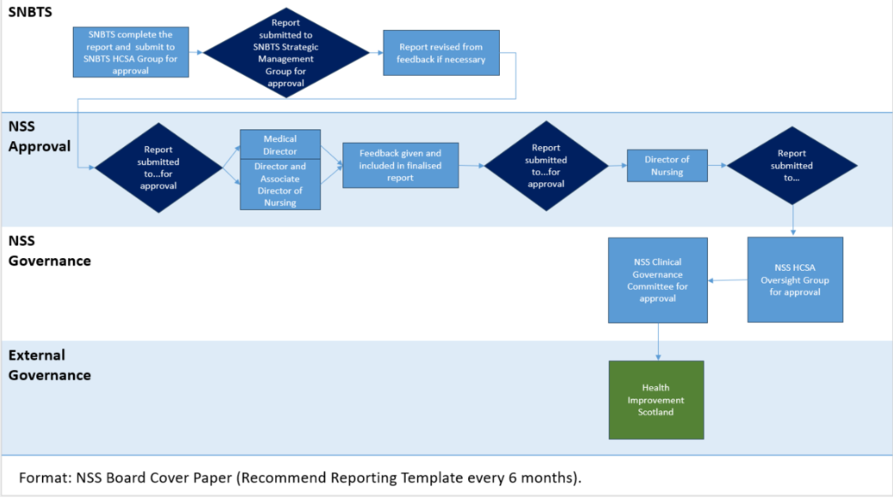

Figure 1. HCSA quarterly reporting process

In last year’s report (April 2025) NSS/SNBTS self-assessed the overall level of assurance of the organisation's compliance with the Act, as substantial assurance. NSS/SNBTS self-assessed themselves green for all subsections of the Act apart from the sub-sections below due to lack of a clear process to record disagreements with clinical advice.

- 121D(2)(f))
- 12IF(1) and 12IF (2) (a)(i) and (ii)
- 12IF (2) (a)(i) and (ii)

An amendment to the real time staffing tool to include clinical advice sought along with space to record any disagreements with clinical advice in the comments box has been made. As a result, NSS can now self-assess these sections as green/substantial reassurance.

Examples of the impact of implementation of the Act in SNBTS:

- All risks which relate to relevant staffing levels have a HCSA tag added. These are tabled at both the SNBTS and NSS Clinical Governance Committees. This clearly highlights the risks related to the Act/clinical staffing and increases visibility.
- Implementation of the Act has raised awareness of SNBTS clinical staff within NSS including with the NSS Clinical Governance Committee.
- The Act has led to documentation of real time staffing for areas within scope. As roll out of eRostering and SafeCare is not completed there has been significant workload to develop and roll out a bespoke real time staffing tool as an interim measure.
- The use of our real time staffing resources help with identifying staffing risk, informing mitigations and evidencing action taken. For SNBTS Patients’ Services laboratories who provide services across a wide geographical area (Aberdeen, Inverness, Edinburgh, Glasgow and Dundee) mitigation largely relies on prioritisation of work or redeploying staff from other duties, often senior staff undertaking benchwork.
- SNBTS are still exploring how to objectively measure both the implementation and the impact of the Act. The real time staffing resource developed by SNBTS can create reports and summarise any mitigations taken. Over the last 9 months, SNBTS has developed quarterly reporting based on this data. It is noted that the real time staffing assessment does not capture the significant amount of work undertaken by managers prior to the shift to ensure staffing levels meet roster requirements. A narrative is now being used to capture other relevant elements, such as work pre shift to meet roster requirements or staffing risks. This is anticipated to give a wider picture of the staffing situation. These reports are being tabled at local operational groups, quarterly reviews and SNBTS HCSA group. A summary of these reports is being tabled at SNBTS Strategic Management Group, NSS HCSA Oversight Group with final approval at NSS Clinical Governance Committee as part of Nurse Directors report.
- Reporting to SNBTS Strategic Management Group and NSS Clinical Governance Committee has moved from reporting solely on compliance with systems and processes to enable implementation of the Act, to focusing on an update on outcomes measures, data and intelligence, for example, number of occasions where staffing levels were appropriate or required escalation, and feedback from staff and service users, and highlighting any emerging issues and risks recorded on the risk management system/InPhase.
- SNBTS have systems in place to allow us to track staff training and monitor / receive feedback on staff leadership capacity, however reporting on these could be improved. Once eRostering has been fully rolled out, there will be an ability to measure and report regularly and consistently on these metrics e.g. % of staff getting protected learning time and leadership time.
- Several KPI have been developed relating to the HCSA which are monitored at the Operatinal Management Group.
- The SNBTS workforce plan and integrated service plan consider the information, intelligence and outputs from the HCSA as part of business-as-usual processes.
- The first phase of the Reduced Working Week (30mins) was implemented in April 2025, the remaining hour will be implemented in April 2026. The structures in place aligned with the Act have helped to ensure essential clinical services are delivered through service redesign or additionality, and determining and securing resource requirements.
- Clinical Apheresis Unit – Nursing staffing levels risk. Long term absence is impacting on service delivery due to small number of specialist staff delivering a specialist service 7 days per week. Impact on workforce, inability of senior charge nurse to get time to lead and potential impact on patient care. This has been identified as a recurrent risk, escalated through appropriate route to a risk on NSS InPhase risk module. Whilst this would have been detected, escalated and managed in a similar way prior to implementation of the Act, this example provides evidence of SNBTS identifying, monitoring and responding to recurrent risk and taking cognisance of adequate time given to clinical leaders (121H). To mitigate this risk there is approval to recruit a fixed term Band 6 with accelerated training and contingency arrangements for patients have been reviewed with Territorial Health Board clinicians informed.
- Concern was raised in one clinical area from the Senior Charge Nurse who highlighted an issue with skill mix. By triangulating staffing and clinical incidents with the professional judgement of the Senior Nurse, there has been a change to the skill mix. Prior to the implementation of the act, the staffing model would have been the over-riding process for determining staffing levels and skill mix within donor services.
- The HCSA has strengthened the need to ensure clinical advice is sought and had regard to, in a more formal way and senior charge nurses/senior nurses are a now a core part of staffing huddles, and critical to decisions made about staffing. The outcomes are documented as part of the safety huddle record and shared with all staff on duty.
- Through the structures of the Act a concern regarding the leadership capacity of Senior Charge Nurses with donor services has been identified and provided evidence to review current supervisory time. As a result, donor services have implemented changes to the Senior Charge Nurses workload by piloting supervisory time of up to 100%.

Please provide information on how your compliance to the Health and Care Staffing Act has led to improved outcomes for service users and workforce
As set out in the legislation, compliance with the Act should support the outcomes from the Health and Care Standards. Therefore, you should demonstrate/consider how implementation of the Act contributes to achieving these Standards.

This should include - but not be limited to - information in relation to patient safety and quality of care measures and outcomes, patient feedback, staff wellbeing measures, and adverse event reporting; what this information has shown and any trends; and any actions taken as a result.

Background

The SNBTS Clinical Governance and Safety Group has the collective responsibility and accountability for clinical governance and blood, cell and tissue products and services quality and safety within SNBTS and for raising issues of concern with the SNBTS Strategic Management Group and/or the NSS Clinical Governance Committee. A quarterly Board paper ‘Blood, tissue and cell quality, safety and sufficiency report’ sponsored by the SNBTS Director is submitted to the NSS Clinical Governance Committee.

SNBTS policies and process for reporting and management of adverse events, incidents, risks, complaints, quality improvement and regulatory compliance are comprehensive and strongly embedded in the QMS which itself is subject to multiple external inspections and licensure against legislation by (inter alia) the Medicines and Healthcare products Regulatory Agency (MHRA); the Human Tissue Authority (HTA); the Human Fertilisation and Embryology Authority (HFEA) and the United Kingdom Accreditation Service (UKAS).
The QMS is documented in several polices including NATP QUAL 043 ‘SNBTS Quality Policy’ and NATS QAD 0117 ‘Quality Manual’. Monitoring of the QMS is a regulatory requirement and is documented in NATP QAL 021. This policy lays out the framework for the QMS review process, reporting and governance route to establish and maintain an SNBTS wide commitment to quality and to the performance of the QMS.
How the Act contributes to outcomes from Health and Care Standards

As highlighted earlier in the report, the requirement to ensure appropriate staffing is a core element of SNBTS regulatory requirements and is embedded with the organisation and QMS. The HCSA has helped strengthen our approach, provide more depth and reliability to the structures in place, improve our ability to report on these and consider how we can demonstrate compliance, impact and outcome. In terms of the currently recorded quality metrics, it is not possible to clearly demonstrate an impact of the Act in terms of outcome measures, however there are a number of measures we continue to monitor (please see Figure 2, 3, 4), alongside other qualitative and quantitative approaches in development. This provides data over time data to inform quality and safety within our systems through compliance and adverse event reporting data, which demonstrates a stable system across these criteria.

- Nursing leadership walk rounds (GEMBA) in clinical areas now include some specific questions about the HCSA which have been positively received by staff. This learning has been fed back directly to areas visited as well as being shared at the SNBTS HCSA Group with consideration of adapting this approach for use in other applicable teams.
- As part of improving data and reporting for improvement and supporting the aims of the Act, we will review the data following a full year of Leadership Walkrounds to identify any themes across the system and actions to address these and revise these questions on an annual basis.
- Feedback from clinical leaders in Donor Services has been that the Act has empowered them in decisions made around staffing and skill mix and that their advice is sought each time a change to staffing or workload is considered.
- In SBARs or business cases for requests for new funding, the Act is being considered or referenced in the narrative and considered in the approval process.
- NSS is registered as a user of CareOpinion, work is underway to pilot promoting CareOpinion with Donor Centres and Clinical Apheresis Units.
- An annual patient feedback survey of Clinical Apheresis Units is completed. From the last several surveys, feedback about staff was positive, there was negative feedback about the environment in terms of limited space and potential impact on confidentiality in the Glasgow centre, a risk has been raised and is being actively managed.
- Complaints, compliments and other feedback is reviewed, and actions taken in regard to the individual feedback and any actions required. This allows SNBTS to track any trends in terms of quality of care and experience. As an example of data available, the Q2 2025/26 report is shared below in Figure 5, demonstrating very small numbers of complaints.
- Data is available on root causes of incidents on a rolling 12-month basis and going forward we will explore if this data can be presented in run charts, to better understand data over time (Figure 6). The data on root causes, as presented, provides powerful data to help understand the system and areas of focus to improve the system and support staff to enable high quality safe services for the benefit of patients and people.
- Excellence in Care has been a key area of focus this year in NSS, with funding (0.2WTE) being made available by Scottish Government to support the programme and engage with National activity. There is strong alignment between these 2 programmes and priorities, enabling a focus on quality of care and workforce. The workforce data has been built into the CAIR dashboard and will be available for validation in Q1 2026/27 and will build additional quality measures where appropriate to enable triangulation of quality and workforce data for nursing roles.
- The NSS NMAHP Strategy was published in 2024 and is a 3-year strategy which has identified EiC, Nursing & Midwifery Taskforce and the Act as keep professional priorities, alongside wider professional issues with a focus on enabling a sustainable workforce. There are a range of activities and deliverables that support compliance with the Act and help drive improved quality of experience and outcomes for people integral to this work.
- NSS is currently implementing the MEG quality data-capture system to allow teams to record quality information directly into this system and enable improved reporting, expanded data sets and reducing data burden for our staff to improve efficiency and effectiveness. The initial implementation has focussed on infection prevention and control data, as the information captured in the leadership walkrounds.

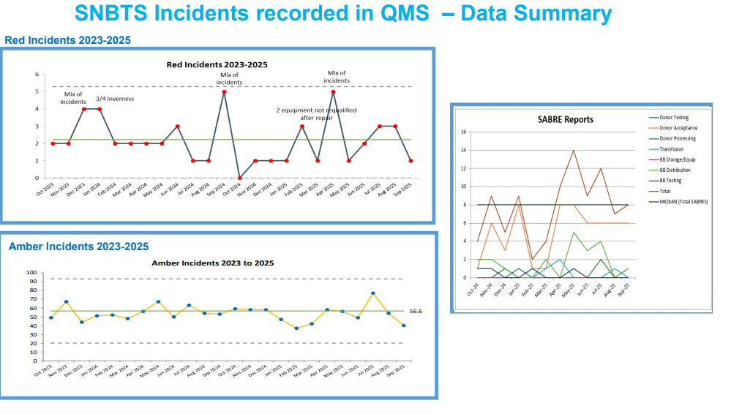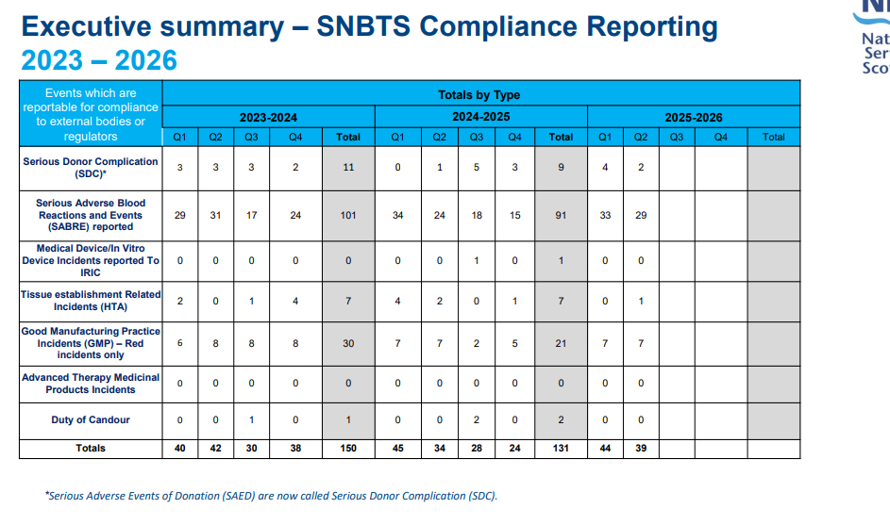

Figure 2. SNBTS red/amber incidents (2023-2025) Figure 3. SNBTS compliance reporting & SABRE reports
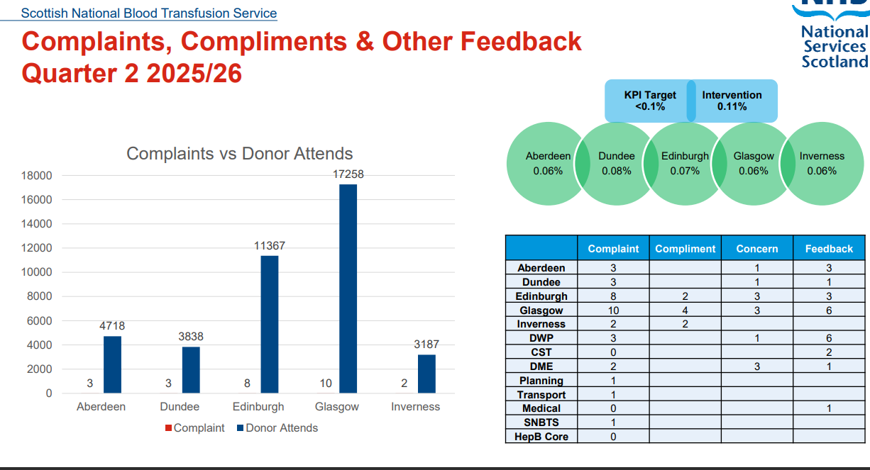

Figure 4. SNBTS Blood Bank MHRA SABRE/SHOT reports Figure 5. SNBTS complaints, compliments and feedback Q2 FY25/26
(2021-2025)
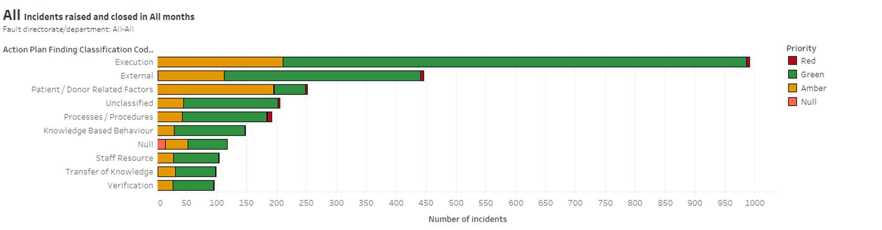
Figure 6. Root causes of incidents on a rolling 12-month basis
Health and Care Staffing Act Health Board Duty Compliance Assurance Levels
Please complete the table below with your Health Boards compliance assurance level for each duty.
DUTY | COMPLIANCE ASSURANCE LEVEL
Duty 12IA: Duty To Ensure Appropriate Staffing | Substantial Assurance
Duty 12IC: Duty To Have Real-Time Staffing Assessment In Place. | Substantial Assurance
Duty 12ID: Duty To Have Risk Escalation Process In Place. | Substantial Assurance
Duty 12IE: Duty To Have Arrangements To Address Severe And Recurrent Risks. | Substantial Assurance
Duty 12IF: Duty To Seek Clinical Advice On Staffing. | Substantial Assurance
Duty 12II: Duty To Ensure Appropriate Staffing: Training Of Staff | Substantial Assurance
Duty 12IH: Duty To Ensure Adequate Time Given To Clinical Leaders. | Substantial Assurance
Duty 12IJ: Duty To Follow The Common Staffing Method (CSM) | Choose an item.
Duty 12IL: Training And Consultation Of Staff | Choose an item.
Planning And Securing Services | Substantial Assurance
PLEASE INDICATE THE OVERALL LEVEL OF ASSURANCE OF THE ORGANISATION'S COMPLIANCE
Substantial Assurance

Duty 12IA: Duty to ensure appropriate staffing
Duty Description | 2 Guiding principles etc. in health care staffing and planning  (1) In carrying out the duty relating to staffing imposed by section 12IA of the National Health Service (Scotland) Act 1978, every Health Board and the Common Services Agency for the Scottish Health Service must have regard to the guiding principles for health and care staffing.  Duty 12IA: Duty to ensure appropriate staffing.  (1) It is the duty of every Health Board and the Agency to ensure that at all times suitably qualified and competent individuals, from such a range of professional disciplines as necessary, are working in such numbers as are appropriate for—  (a) the health, wellbeing, and safety of patients,  (b) the provision of safe and high-quality health care, and  (c) in so far as it affects either of those matters, the wellbeing of staff.  (2) In determining what, in a particular kind of health care provision, constitutes appropriate numbers for the purposes of subsection (1), regard is to be had to—  (a) the nature of the particular kind of health care provision,  (b) the local context in which it is being provided,  (c) the number of patients being provided it,  (d) the needs of patients being provided it, and  (e) appropriate clinical advice.
Please provide information on the steps taken to comply with Duty 12IA.
Please provide information to demonstrate compliance.

Information submitted here should outline how systems & processes take account of all of the points detailed in the duty description above by providing detail for each consideration.

Guiding principles etc. in health care staffing and planning - examples of how SNBTS has regard for guiding principles:

Improving standards and outcomes for service users
This has been laid out in the summary section above.

Taking account of the needs, abilities, characteristics and circumstances of different service users
NSS has reviewed and updated the Equality Impact Assessment (EQIA) and associated guidance, listening to feedback from staff and stakeholders to ensure it supports practice and the user to undertake a comprehensive assessment. As part of the policy review NSS has introduced an Equality Impact Screening Assessment to help assess a service or policy development and determine if a full EQIA is required. All reports, policies or service development papers must be accompanied by an EQIA screening assessment document to ensure these criteria are considered. This launch was supported by effective all staff communications as well as presentation at different leadership forums to support staff and managers implement this new change.

We use feedback – formal and informal, to ensure the views of our service users are being considered and use this feedback to review and develop our services. An example, following feedback, SNBTS has amended its process to support donors that may require malaria antibody testing to donate and have the test and donation undertaken in a single visit, rather than 2 separate visits which was standard practice. This has increased donor access as evidenced by an increase in blood donations.

The public and service user feedback and engagement have been integral to the development of the SNBTS Strategy and has ensured the voice of our service users are an essential consideration as we develop our services and commitments for the next 5 years. This keeps our strategy relevant and ensure our services and supportive, accessible and can support the needs of our patients and donors.

Respecting the dignity and rights of service users
Respecting the dignity and rights of service users is a priority that is embedded in our core business and values. SNBTS undertakes a quarterly review of complaints, feedback and compliments, looking for themes and where possible addressing these. SNBTS undertakes and responds to user surveys e.g. blood bank user survey, blood donors and patients attending the Clinical Apheresis Units. The 2024 Clinical Apheresis Units patient surveys provided excellent feedback on the professionalism of staff but highlighted space issues within the Glasgow unit. The hospital footprint makes this difficult to address along with financial constraints to undertake accommodation changes, some minor remedial work has been progressed, and a risk has been raised on NSS Integrated risk management system/inPhase. The survey results are displayed in the Clinical Apheresis Units.

Taking account of the views of staff and service users
Within NSS/SNBTS we welcome and actively encourage the views of staff and service users, and are working to further develop and expands these, as well as consider how the outputs are incorporated into our day-to-day service delivery and service planning. There are the formal routes e.g., feedback, iMatters and complaints, as well as informal via staff developments days and sessions, staff huddle feedback, outcomes from meeting agendas etc...

As part of NMAHP strategy and EiC, work on What Matters To You (WMTY) for staff and donors has been an area of focus providing a broad range of structured and unstructured feedback that is being used to inform and define future ways of working, team development and to ensure we are providing person-centred services.

Listening to patients has identified quality improvement activity to develop services to meet the needs of people – an example is the work the Glasgow CAU team have done, listening to patients and working with other professionals to improve pathways and communication between clinicians and people with sickle cell anaemia, and ensure workforce plans reflect the needs and support efficient and effective ways of working and deployment of staff.

SNBTS has undertaken a range of the engagement to inform the SNBTS strategy 2025-2030. Public and service user engagement and feedback continues to be an important element of SNBTS activity, in particular given the unique nature of donor services, to encourage and enable donors to give their time and to value their contribution.

SNBTS will commence work with Health Improvement Scotland in January 2026 to complete self-assessment against HIS Quality Framework for Community Engagement and Participation - Domain 1: Ongoing Engagement and Involvement of People.

Ensuring the wellbeing of staff
NSS are committed to enabling and ensuring the wellbeing of staff, building a sustainable and valued workforce and making NSS a great place to work. To support these values and ambitions there are a number of approaches and strategic priorities to support and ensure the wellbeing of staff. Examples include;
- The use of iMatter as a measure of staff wellbeing with local action plans to respond to individual feedback form teams – good engagement with staff in NSS, with an overall staff response of 77%.
- The work of the NSS Well Being group,
- NSS Wellbeing Hub,
- Whistleblowing and access to confidential contacts,
- NSS Great Place to Work Action Plan,
- Anti-Racism Plan,
- Building workforce sustainability by developing Quality Improvement capability, confidence and compassionate, person centred leadership (for example, through the NSS Quality Improvement and Value Skills Course),
- Undertaking learning about What Matters to You for staff - Donor services have introduced What Matters to You programme in the nursing teams and this is being positively received by staff. There is an intention to roll this out further across SNBTS,
- TCAT have established a Wellbeing group that meets every 2 weeks and have introduced a number of initiatives to support staff’s wellbeing,
- Incorporating staff feedback more formally into the Leadership Walkrounds.

Being open with staff and service users about decisions on staffing – Communication and training of staff with regards to the Act has been undertaken. The Act has been included in induction training and TURAS modules are part of role specific training. Supporting documentation has been developed to ensure feedback to staff (NATL 424).

Staff huddles – work has been undertaken to ensure staff huddles are more inclusive of all staff, with feedback and documented notes then shared live with team for their awareness, input and feedback. Staffing concerns and escalation addressed real-time and feedback to staff involved is provided verbally as well as captured in huddle update. The safety huddles are recorded and shared with staff to ensure transparency about decision made regarding staff, with communicated routes of escalation to support staff with concerns. Staff were able to provide evidence and examples of this process in practice during leadership walkrounds.

Staff are engaged with staffing reviews, workforce plans and integrated service plans, and the feedback and experience from the Act informs these. The outcome from this work is shared with staff through staff meeting and huddles as appropriate.

Allocating staff efficiently and effectively
As described in the summary, ensuring sufficient safe staffing levels continues to be a core of business-as-usual work and is integral to SNBTS regulatory requirements, both in terms of mitigating the risk in real time, addressing longer term issues and escalation of risk. With regard to the Act, where processes were not documented these have now been documented to meet the requirements of the Act i.e. recording of real time staffing, although further work is required to enable robust and consistent reporting on these.

Overarching and service specific workforce plans consider Six Step methodology and incorporate the inclusion of local context and reflect dynamic service review and planning. The duties or the Act have been mapped against the workforce planning methodology to ensure the information, data and intelligence from the Act becomes integral to workforce planning.

There are quarterly workforce planning reviews within each service in SNBTS to consider actions, risks to explore considerations towards service redesign, realignment of the organisational structure to support the professional leadership and associated internal strategies e.g. Nursing Strategy. Additionally, to review Workforce Planning Heat Maps of specific skill sets that are niche to the workforce and services and enable effective succession planning and re-profiling requirement of role structure of services and appropriate and identified through national agendas /strategies and the 5-pillar action plan to underpin the principles and evidence practice of safe staffing.

The SNBTS Nursing Strategy 2025-2028 ‘Empowering Staff, Supporting Donors, and Transforming Patient Care’ was published in Winter 2025 following a period of collaboration and co-production with the nursing team. The strategy outlines key commitments to delivering an effective person-centred service for donors, patients and staff. A summary is provided in Figure 7, outlining the key commitments over the 3 year plan.

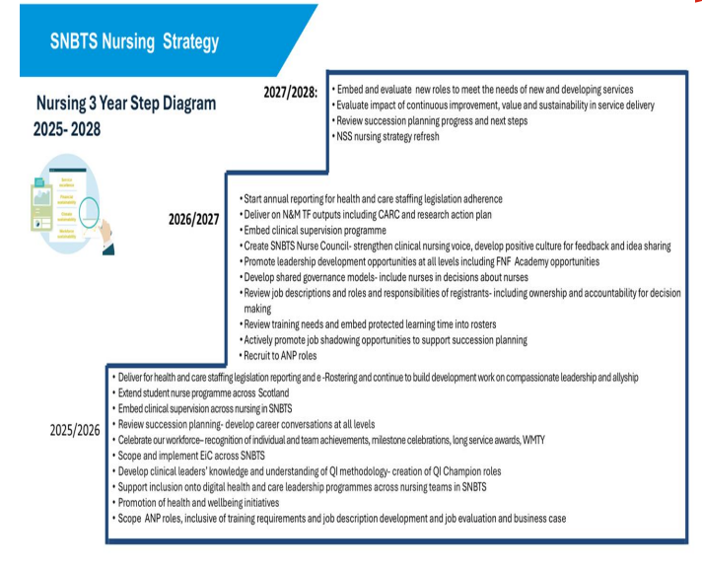
Figure 7. SNBTS Nursing Strategy 2025-2028

A formal HR data report (including sickness absence, leavers) is considered at monthly at the SNBTS Strategic Management Group to identify and respond to any emerging trends.

Promoting multi-disciplinary services as appropriate
SNBTS Patient Services undertakes multidisciplinary workforce planning using the Six Step methodology. These groups include clinical and professional representation.

As part of vacancy management and workforce planning, our approach considers skills required and ensure these opportunities can be offered to all professions with the relevant skills to optimise the staff available and ensure equitable access to staff development.

As a result of identifying medical staffing risks, an advanced nursing practice model is being developed to deliver a broader MDT approach to support clinical needs across our CAU services.

Duty 12IA: Duty to ensure appropriate staffing

NSS has developed a policy to support implementation of the Act ‘NHS National Services Scotland Health and Care (Staffing) (Scotland) Act 2019 Guiding Principles and Duties’. The purpose of this policy is to provide support and guidance for all staff, including those staff who have a responsibility for decision making relating to staffing on a shift by shift or longer-term basis involved in the escalation of a staffing risk, may be required to provide professional advice to inform decision making regarding a real-time risk, escalated risk or identified recurrent risks. Additionally, this guidance outlines key requirements, considerations and principles for wider workforce planning of clinical services in NSS. SNBTS has further documents (policies and standard operating procedures) supporting implementation of the Act within SNBTS.

SNBTS Health and Care (Staffing) (Scotland) Act (HCSA) Implementation Project Delivery Group, chaired by the SNBTS Medical Director, established in July 2023, is responsible for the Act implementation and oversight to ensure that the requirements Act are met. There is representation from all professional groups and teams in scope on this group. The terms of reference documents the group’s reporting structure to SNBTS Strategic Management Group chaired by the SNBTS Director. This group now meets quarterly, with focus shifting from implementation to considering how we might objectively measure success in implementation, beyond subjective self-assessment, and assess the impact of the Act.

It should be noted that there is no speciality specific validated HIS staffing level tools for the staff groups in scope within SNBTS. Following the launch of the Multi-disciplinary Professional Judgment Tool (PJT) in 2025 SNBTS is keen to use this resource to support workforce planning and triangulation of current workforce planning information and intelligence and is exploring how this could best apply across our different services and professions integral to current processes.

NSS/SNBTS provide both direct and indirect healthcare, for direct patient services staffing requirements are informed using locally developed workforce tools, for example, the Donor Services Collection Teams and Patient Services Clinical Apheresis Workforce planning tools. In these bespoke staffing model, there is the capacity to identify workload capacity and related skill mix and staffing levels to understand if changes to numbers of appointments are required to maintain safety, however this will also be supported by the clinical judgement of the session manager / team leader / senior charge nurse. Similar processes exist for the other nursing teams in scope. There are also several bespoke staffing models in existence across the range of services in SNBTS which provide guidance for staffing levels, the HCSA has strengthened the need to ensure clinical judgement is considered alongside these tools. With the introduction of the multi- disciplinary PJT there will be the opportunity to apply this alongside local staffing tools to further develop and strengthen the structures and approaches in place.

As a requirement for UKAS accreditation, and considering demand, capacity and skill mix requirements staffing capacity plans exist in several service areas including Patient Services laboratories and medical staff. Within the Manufacturing Unit minimum shift staff numbers exits that consider workload and skill mix.

As described in the summary, SNBTS must comply and are inspected against the relevant regulators’ requirements which consider staffing requirements and inform workforce planning requirements.

Workforce planning

The Annual Integrated Service Planning includes consideration of workforce; in November 2025 the current workforce was 912.5 WTE (not all these staff are in scope for reporting on the Act). There were 55 WTE vacancies, most within the job families reporting under the Act. These require to be filled to maintain safe staffing and service provision, but the vacancies add additional workforce pressures particularly in areas that support out of hours rosters 24/7/365. Vacancy is largely due to staff turnover and time taken for vacancy management process. A net increase of 11 WTE is proposed over next financial year relating to clinical workforce to cover additional, or expanding programmes of work i.e. IBI recommendations, plasma collection. All vacancies are reviewed at the NSS Vacancy Management Group to ensure robust oversight and governance of all staff vacancies.

Within NSS, there is a professional lead for all professions in scope. Within SNBTS out of hours medical and nursing staff rotas exists, so clinical advice is always available. Medical, health care scientist and nursing leads are available in all areas of the service and documented in organisational organograms e.g. ORG MED 01.

Clinical staff and professional leads attend workforce planning and quarterly performance reviews or so there is appropriate clinical and professional visibility of staffing issues and involvement in decision making. Finance limitations are considered against the request for additional staff. The requirement for robust business cases is essential to support increases in staffing requirements, especially in the context of service level expansion.

NSS has a budget summit each year to review directorate Integrated Service Plans and ensure strategic priorities are part of a whole system approach.

Reduced Working Week

The Reduced Working Week (RWW) for Agenda for Change (AfC) staff - as agreed to as part of the 2023–24 pay negotiations – will impact service capacity and has been an essential consideration as part of our workforce planning over recent years, with the most significant reduction of 1-hour effective April 2026. The RWW has required changes to roster planning and shift patterns, which has increased the workload for service leads, to ensure that rosters are effective and make best use of our staffing resource, whilst ensure we have the capacity to deliver safe high-quality services.

Following the review in SNBTS across different professions to consider different ways of working, workforce capacity and skill mix requirements, there is a requirement for an additional 14.80 WTE to ensure appropriate staffing is in place following the RWW hour reduction from April 2026 for clinical staff working on nonstandard/out of hours rosters.

Following the review current plans for standard rosters for both clinical (e.g. National Microbiology Reference Unit) and support staff (e.g. admin and quality assurance staff) workload will be absorbed, and pressures on support staff will be monitored to ensure there is no detriment on clinical staff workload and workflow.

We are proactively working to review staff learning time requirements, considering the Protected Learning Time (PLT) guidance for statutory training and role specific training. Current indications suggest that PLT may increase to around 5% or 6% compared to the baseline 2% presently used for workforce planning purposes and likely to impact upon workforce availability and resilience.

Please provide Information on your methods of monitoring compliance with Duty 12IA
This should include details of the local arrangements in place to monitor compliance with the duty, including mechanisms for escalating and addressing areas of non-compliance.

Most of the processes described above were in place prior to implementation of the Act, in part due to the legal and regulatory framework SNBTS required to work within. SNBTS has used its existing process to evidence compliance with the Act, however we recognise there is the opportunity to strengthen these and improve reliability using SafeCare, and SafeCare reporting.

SNBTS Health and Care (Staffing) (Scotland) Act (HCSA) Implementation Project Delivery Group is responsible for the Act implementation and oversight to ensure that the requirements of this duty (12IA) are met. NSS oversight is provided by NSS HCSA Oversight Group (established July 2025).

Both groups are focussing on how we go beyond compliance with the duties to consider and capture the ‘so what’ in a meaningful way, that more reliably demonstrates impact and outcomes for service users and staff. There is a significant amount of relevant information shared at multiple fora across the organisation but there remains challenge in fully triangulating the data in a meaningful way and feeding this into the relevant groups, and this will remain a priority for these groups to progress in 2026/27.

SNBTS’s major barrier to the consistent application and implementation and reliable monitoring of compliance of the Act is around delays to implementation of eRostering. This has resulted in SNBTS developing local systems and manual process to support gaps in compliance with the Act e.g. development of a processes for real time staffing assessment, recording of clinical advice and recording risks below the level that triggers formally raising a risk within the integrated risk management system/inPhase. There are processes in place which can be evidenced via policies and procedures but there is a lack of easily accessible data to measure the impact of compliance with the Act.

NSS has prioritised rollout of the Allocate Optima system with go live planned for end of FY2025/26. There have been technical difficulties in rolling this out to medical and dental staff. This has now been resolved and NSS medical and dental staff are built into the Allocate Optima system based on existing data from eESS and SSTS (using a basic roster without incorporating Activity Manager). Further understanding and training in how the Allocate Optima system could provide data and allow triangulation of data to support the Act is required.

SafeCare implementation is dependent on implementation of Allocate Optima system. NSS are expecting to implement SafeCare in FY2026/27, this implementation is dependent on the provision of national guidance for medical and dental staff. NSS are working with the national eRostering team.

Service areas are pulling data from the real-time staffing tool and other sources, such as risks, supported by a narrative to provide quarterly reporting to department operational groups that also feed into workforce planning groups and quarterly performance reviews with the SNBTS Director. This data is reported into the SNBTS HCSA group and then pulled into an overarching quarterly report that is submitted to SNBTS Strategic Management Group, NSS HCSA Oversight Group and NSS Clinical Governance Committee (see Figure1).

Glossary
eRostering
An overarching term that encompasses the electronic rostering system and its associated modules used to manage staffing schedules and ensure appropriate staffing.
Allocate Optima
NHS Scotland’s national eRostering software suite used to manage workforce deployment.
SafeCare
A module within the Allocate Optima system that supports real-time staffing decisions based on patient acuity.

Areas of success, achievement, or learning

Area of success / achievement / learning | Details | Further action
This should include details of the NHS function / professional group etc. that the area of success, achievement or learning relates to. | This should describe the situation: what is the success, achievement, or learning?  For example, application of eRostering has allowed senior personnel to be able to see staffing in real-time across all areas, allowing staff to be reallocated as required to reduce level of risk. | This should describe how the success, achievement or learning could be used in the future.  For example, continue the roll out of eRostering across the organisation, using learning from areas that have already implemented.
SNBTS wide – SNBTS Nursing Strategy 2025-2028 | SNBTS Nursing Strategy 2025-2028 ‘Empowering Staff, Supporting Donors, and Transforming Patient Care’ was published in Winter 2025. | SNBTS will continue to grow our student nurse programme across the country to enable further development of our NSS and NES approved undergraduate placement learning environment. This will allow us to highlight the breadth and complexity of the opportunities for nursing across SNBTS and to expose student nurses to future career options, including those across NSS.
Internal reporting/triangulation of data | Some service areas are pulling data from the real-time staffing tool and other sources, such as risks, supported by a narrative to provide quarterly reporting to department operational groups that also feed into workforce planning groups and quarterly performance reviews with the SNBTS Director. This data is reported into the SNBTS HCSA group and then pulled into an overarching quarterly report that is submitted to SNBTS Strategic Management Group, NSS HCSA Oversight group and NSS Clinical Governance Committee. | Extend this to all service areas.
Clinical Apheresis Unit – Nursing staffing levels | Long term absence is impacting on service delivery due to small number of specialist staff delivering a specialist service 7 days per week. There is a negative Impact on workforce, inability of the senior charge nurse to get time to lead and potential impact on patient care. This is a recurrent risk, escalated through appropriate routes and recorded on InPhase risk management module (December 2025). This would have been detected, escalated and managed in a similar way prior to implementation of the Act but does evidence SNBTS taking cognisance of adequate time given to clinical leaders (121H). | Plan to recruit fixed term Band 6 with accelerated training, contingency arrangements for patients reviewed and risk raised. This risk is on InPhase with HCSA tag and has been visible at SNBTS Clinical Governance and Strategy Group and NSS Clinical Governance Group due to application of HCSA tag.
Donor services - Nursing | Triangulation of data using staff feedback, incident reporting and real time staffing data has enabled a change in skill mix at a specific donation session type. Staff report feeling more empowered around their professional judgement. | Quarterly reporting from real time staffing monitoring alongside review of incidents and staff feedback is ongoing.

Areas of escalation, challenges, or risks

Area of escalation / Challenge / Risk | Details | Further action
This should include details of the NHS function / professional group etc. that the area of escalation, challenge or risk relates to. | This should describe the situation: what is the challenge or risk identified?  For example, there may be difficulty with recruiting a particular staff speciality or recruitment in a remote / rural location. | This should describe what actions have been / are being / will be taken to address the situation.  For example, if there is difficulty in recruiting in a particular speciality or remote / rural location, the relevant organisation may have investigated retire and return schemes or upskilling and career development for existing staff. It may also have looked at how the service could be redesigned.
SNBTS wide – Implementation for Reduced Working Week (RWW) for Agenda for Change Staff | The RWW - as agreed to as part of the 2023–24 pay negotiations – is predominately impacting 24/7 rosters and the associated staffing levels and skill mix requirements on each shift compounded with a number of staff currently undergoing structured training programmes and unable to be fully included in 24/7 rosters until training has been successfully signed off. The RWW has required changes to roster planning and shift patterns, which has temporarily increased the workload for service leads until roster changes have been collectively agreed and submitted for implementation i.e. e-rostering. In addition to high volume of part time staff wishing to revert to pre RWW hours.  There will be an additional 14.80 WTE required to offset the addition RWW hour reduction from April 2026 for clinical staff working on nonstandard/out of hours rosters. It should be noted that for standard rosters for both clinical (e.g. national microbiology reference unit) and support staff (e.g. admin and quality assurance staff) workload will require to be absorbed. Although not captured within the scope of the Act, pressures on support staff often have a direct impact on clinical staff workload and workflow. | Continue to monitor impact of RWW. Implementation of Protected Learning Time.
SNBTS wide - evidencing compliance with the Act | Delays to implementation of eRostering systems are impacting on progress. | Escalation to eRostering Programme Board and NSS HCSA Oversight Group.
SNBTS Wide – assessment of impact of Act | Concerns that there are insufficient resource and expertise within NSS eRostering team and SNBTS to realise the full functionality and benefits of eRostering. | Escalation to eRostering Programme Board and NSS HCSA Oversight Group.
Healthcare Scientists (Biomedical Scientists (BMS)) in Patient Services, in particular Inverness and Aberdeen Blood Banks | Inverness Blood Bank has significant ongoing recruitment and retention issues across the Biomedical Scientist profession. The Blood Bank provides a 24/7/365 clinical transfusion provision to NHS Highland patients. There is a 12-person roster to provide out of hour services. The team has been unable to achieve a 12-person roster. This requires individuals to cover shift gaps on the roster, there has been numerous occasions of Safe Staffing escalation as gaps have not been able to be covered by the local team. This ongoing risk is on the NSS risk register and has had to be upgraded to a red risk again due to a period over the summer of 2025 where significant service mitigations required to be deployed over 3 consecutive weekends.  It takes approximately 12-18 months for a trainee BMS to qualify and be registered with the Health and Care Professions Council (HCPC). If a qualified BMS is recruited it will take approximately 12 months to train them for out of hour lone working.  Aberdeen – retention challenges. | Actions taken, the Inverness establishment has been increased and additional senior staff recruited. Secondment cover of Band 6 BMS and senior staff from other sites, this is a significant undertaking. Accelerated training programmes where safe to deploy. Locum cover.  About to support two retire and returns.  Tried to address the terms and conditions around working up to protection (no volunteers coming forward).  Improvements in technology with the implementation of Smart Fridges to support electronic release of blood units.  Aberdeen – have self managed and continue to support their training programme to ensure they have sufficient out of hour service provision.

COMPLIANCE ASSURANCE LEVEL
Substantial Assurance

Duty 12IC: Duty to have real-time staffing assessment in place.
Duty Summary | (1) It is the duty of every Health Board and the Agency to put and keep in place arrangements for the real-time assessment of its compliance with the duty imposed by section 12IA.  (2) The arrangements under subsection (1) must, in particular, include—  (a) a procedure for the identification, by any member of staff, of any risks caused by staffing levels to—  (i) the health, wellbeing, and safety of patients,  (ii) the provision of safe and high-quality health care, or  (iii) in so far as it affects either of those matters, the wellbeing of staff,  (b) a procedure for the notification of any such risk to an individual with lead professional responsibility (whether clinical or non-clinical) in the area where the risk was identified,  (c) a procedure for the mitigation of any such risks, so far as possible, by such an individual, and a requirement for that individual to seek and have regard to appropriate clinical advice, as necessary, in carrying out such mitigation,  (d) raising awareness among staff about the procedures described in paragraphs (a) (b) and (c),  (e) encouraging and enabling staff to use the procedures described in paragraphs (a) and (b),  (f) training individuals with lead professional responsibility (whether clinical or non-clinical) for particular types of health care in how to implement the arrangements put in place under paragraphs (a) to (e), and  (g) ensuring that such individuals receive adequate time and resources to implement those arrangements.
Please provide information on the steps taken to comply with Duty 12IC.
Please provide information to demonstrate compliance.

Information submitted here should outline how systems & processes take account of all of the points detailed in the duty description above by providing detail for each consideration.

Real time staffing assessment

The Act requires NSS to implement systems that allow recording of real-time assessment of staffing levels across services.
Ensuring real time safe staffing levels has always been a core of business-as-usual work, both in terms of mitigating the risk in real time and escalation of risk. Where processes were not documented these have now been documented to meet the requirements of the Act.

The delays in implementation eRostering and SafeCare has resulted in SNBTS having to develop manual processes to support gaps in compliance with the Act on an interim basis including development of a processes for recording real time staffing assessment including recording of clinical advice.
A bespoke real-time assessment staffing tool (excel spreadsheet) is in place for all staff in scope in SNBTS. This was developed and tested using a plan do study act (PDSA) approach. The excel spreadsheets for each service area are held on a dedicated SharePoint site. There is a supporting standard operating procedure (NATS CLS 173 ASSESSMENT AND RECORDING OF APPROPRIATE STAFFING LEVELS FOR SNBTS CLINICAL GROUPS and NATS COL 117).

It is not possible to complete a real-time assessment staffing tool for the lone post of SNBTS Infection Prevention and Control Manager (IPCM) or the Consultant Haematologist, Dundee Regional Transfusion Centre, Ninewells. Risk assessments have been completed for both posts. Cross cover for the IPCM is provided by Antimicrobial Resistance & Healthcare Associated Infection Scotland (ARHAI) and works well. Cross cover for the Consultant Haematologist is via the national in hours on call consultant rota and works well.

Local arrangements in place to complete real-time staffing assessment using a locally developed RTS assessment resource which consider the planned workload (demand) against staff available, to help monitor staffing levels and respond to changes dynamically.
Within SNBTS the person in charge of an area (for example, senior charge nurse / team leader) is responsible for assessing that the staffing complement is sufficient to provide safe, effective and high-quality care, and that the team is assessed as being appropriately staffed, taking into consideration workload (activity), patient acuity, dependency and skill mix.
The person in charge must review the staff available against real-time clinical demand and use their professional judgement to determine if there is sufficient staff, or trigger escalation protocols to address risks quickly.
All areas operate dynamic risk assessment and escalation either through use of safety huddles or in response to unplanned absence/vacancy which impact staffing levels. This is supported by recording of real time staffing assessment. The activity of lead professionals and senior decision makers related to management of risk escalation and management of risk is routinely incorporated into daily work activities.

Mitigations generally relate to workload (re) prioritisation or within donor services reduction of blood and blood component donor appointments as the wide geographical distribution and specialism of staff makes it difficult to transfer staff between sites within an individual shift. Procedures (e.g. NATS CLS 173, NATS COL 117, NATS CLIN APH 050, TCATS NUR 024) describe possible mitigations and when and how to seek clinical advice if that person is not suitable trained or qualified to provide clinical advice. There is also recorded business continuity plans for services which encompass managing clinical risk, informed by clinical advice, as part of our NSS resilience planning.

Staff awareness and training

Communications have been issued to staff by both NSS (2 April 2024) and SNBTS (16 April 2024) to raise awareness of the Act, and these are embedded in practice and ways of working. The requirements of the Act are also embedded in relevant policies and ongoing staff activity and communication to support elements of the Act on an ongoing basis.

SNBTS has developed supporting documentation for staff relating to the Act. This includes an overarching policy (NATP CLIN 063) and flow chart guidance (NATL 424) which describes the overarching process for raising and escalation of any risk caused by staffing levels. Also, guidance around the assessment and recording of appropriate staffing levels for health care scientist and medical and nursing staff (NATS CLS 173, NATS COL 117, NATS CLIN APH 050, TCATS NUR 024) has been developed.

Training presentations (both in terms of the Act itself and the use of the real time assessment staffing tool) were made available to support local managers with roll out of the Act.

HCSA has been added to induction checklist for all staff. It will shortly be added to the SNBTS digital induction platform ‘Articulate’.

The SNBTS induction training/training matrix has been updated to include the relevant TURAS modules.

Senior leadership walkarounds (nursing) (GEMBA) includes staff questions relating to HCSA, which checks nursing staff awareness of the Act and would identify any potential issues.

The rostering process provides opportunity for staff to highlight risks prior to the session/shift taking place. All staff can raise a risk or concern through the team leader or line manager, or at the different daily huddles/ staff review or handover discussions

Staff can also raise concerns beyond their manager as part of the NSS raising concerns process which includes sign posting to processes such as whistleblowing when appropriate. Whistleblowing is part of mandatory training for all NSS staff.

Please provide Information on your methods of monitoring compliance with Duty 12IC
This should include details of the local arrangements in place to monitor compliance with the duty, including mechanisms for escalating and addressing areas of non-compliance.

SNBTS Health & Care Staffing Act Implementation Project Delivery Group continue to meet and NSS has established an NSS Oversight Group (July 2025).

There are processes in place for real time staffing assessment and recording which can be evidenced via policies and procedures.

Service areas are pulling data from the real-time staffing tool and other sources, such as risks, supported by a narrative to provide quarterly reporting to department operational groups. This is providing assurance that real time staffing tools are being completed. These reports are also feed into workforce planning groups and quarterly performance reviews with the SNBTS Director.

Operational managers contribute to the quarterly HCSA report to provide oversight and triangulation of data, providing information and analysis on what the data is telling us, and any actions, mitigations or escalations as a result. The following are considered in the reporting process - disagreements with clinical advice relating to staffing, outputs from real-time staffing tool, narrative on staffing issues, InPhase staffing risks and KPIs. This provides assurance in regard to compliance with the duty, both in terms of undertaking real-time staffing assessments, as well as how the information is used to ensure appropriate staffing on a day-to-day basis, understanding frequently occurring risks and informing future workforce planning. This is submitted to by SNBTS HSCA group, SNBTS Strategic Management Group, NSS HCSA Oversight group and NSS Clinical Governance Committee.

Non-compliance would be identified through the scrutiny of reports and actions to address non-compliance through board governance structures, with support and direction from the NSS HCSA Oversight Group.

Areas of success, achievement, or learning

Area of success / achievement / learning | Details | Further action
This should include details of the NHS function / professional group etc. that the area of success, achievement or learning relates to. | This should describe the situation: what is the success, achievement, or learning?  For example, areas that have implemented and are using SafeCare are able to accurately record risks that are identified and the mitigation measures implemented, and clinical advice received. Reports extracted from the system are demonstrating an auditable trail of decision-making. | This should describe how the success, achievement or learning could be used in the future.  For example, this success is being used to demonstrate to other areas the benefits of using SafeCare and supporting its implementation.
Enhanced version of the real time staffing tool resource implemented across Nursing teams to provide improved data and evidence on activities to support the Act. | A decision was made to implement a more detailed version of the local real time staffing tool being used within other parts of SNBTS in the absence of SafeCare. This has provided improved data capture and evidence activities to support the Act and help prepare staff for SafeCare requirements. | Support the implementation of SafeCare in 2026/27, and improved reporting and monitoring across all domains.
SNBTS wide - compliance with the Act | Development of a multidisciplinary and service wide group to oversee implementation of Act and shared processes and documentation means there is unified approach across all services and professions. | Implementation of SafeCare would standardise and improve this further.
SNBTS wide – all staff in scope | Operational managers are contributing to a quarterly HCSA report to provide oversight and triangulation of data. The following should be considered in the reporting process - disagreements with clinical advice relating to staffing, outputs from real-time staffing tool, narrative on staffing issues, InPhase staffing risks and KPIs.  This provides evidence of completion of real-time staffing in lieu of SafeCare. | Continue to develop this and consider incorporating outputs from eRostering systems once rolled out.

Areas of escalation, challenges, or risks

Area of escalation / Challenge / Risk | Details | Further action
This should include details of the NHS function / professional group etc. that the area of escalation, challenge or risk relates to. | This should describe the situation: what is the challenge or risk identified?  For example, there may be difficulty with encouraging and enabling certain professional groups to use the systems and processes. | This should describe what actions have been / are being / will be taken to address the situation.  For example, if there is difficulty in engaging certain professional groups, what measures have been put in place with regard to increasing this such as using professional networks, staff representatives etc.?
SNBTS wide - evidencing compliance with the Act | Delays to implementation of SafeCare are impacting evidencing compliance with the Act.  SafeCare implementation is dependent on implementation of Allocate Optima system. NSS are expecting to implement SafeCare in FY2026/27, this implementation is dependent on the provision of national guidance on medical and dental staff. | Measures as described above are in place to ensure SNBTS are considering a recording real time staffing.  eRostering Programme Board are aware of dependency of SafeCare on HCSA.  SNBTS HR Business partner sits on both SNBTS HCSA delivery group and NSS eRostering Programme Board.  NSS eRostering delivery team in liaison with eRostering national Programme Board on national guidance on medical and dental staff.

COMPLIANCE ASSURANCE LEVEL
Substantial Assurance

Duty 12ID: Duty to Have Risk Escalation Process in Place.
Duty Summary | - It is the duty of every Health Board and the Agency to put and keep in place arrangements for the escalation of any risk.  - identified during the real-time assessment of its staffing levels in accordance with arrangements put in place under section 12IC, and  (b)which it has not been possible to mitigate in accordance with the arrangements put in place under that section.  (2) The arrangements under subsection (1) of this duty must include:  - A procedure for the initial reporting of a risk as described in subsection (1), by an individual with lead professional responsibility (whether clinical or non-clinical) in the area where the risk was identified, to a more senior decision-maker,  - A requirement for any such decision-maker to seek and have regard to appropriate clinical advice, as necessary, in reaching a decision on the risk, including on how to mitigate it,  - A procedure for the onward reporting of the risk, as necessary, to a more senior decision-maker in turn, and a requirement for that decision-maker in turn to seek and have regard to appropriate clinical advice, as necessary, in reaching a decision on the risk, including on how to mitigate it,  - A requirement for the arrangements put in place under paragraph (c) to escalate further in order to reach a final decision on the risk, including in appropriate cases by the reporting of the risk to the members of the Health Board.  - A procedure for the notification of every decision made following the initial report, and the reasons for it, to:  (i)any individual who was involved in identifying the risk in accordance with the arrangements put in place under section 12IC(2)(a),  (ii)any individual who was involved in attempting to mitigate the risk in accordance with the arrangements put in place under section 12IC(2)(c),  (iii)any individual who was involved in reporting the risk in accordance with the arrangements put in place under paragraph (a), (c) or (d) of this subsection, and  (iv)any individual who gave clinical advice in accordance with the arrangements put in place under section 12IC(2)(c), or under paragraph (b), (c) or (d) of this subsection,  - A procedure for those individuals to record any disagreement with any decision made following the initial report,  - A procedure for those individuals to be able to request a review of the final decision on a risk (other than a final decision made by the members of the Health Board or the Agency) made in accordance with the arrangements put in place under section 12IC(2)(c) or, as the case may be, paragraphs (b), (c) or (d) of this subsection,  - Raising awareness among staff about the procedures described in paragraphs (a) to (f),  - Training individuals with lead professional responsibility (whether clinical or non-clinical) for particular types of healthcare, and other senior decision-makers, in how to implement the arrangements put in place under paragraphs (a) to (h), and  - Ensuring that such individuals receive adequate time and resources to implement those arrangements.
Please provide information on the steps taken to comply with Duty 12ID.
Please provide information to demonstrate compliance.

Information submitted here should outline how systems & processes take account of all of the points detailed in the duty description above by providing detail for each consideration.

Prior to the implementation of the Act SNBTS already managed staffing/clinical risks via the NSS Integrated Risk Management Policy (IRMA). SNBTS has developed supporting documentation to describe how it complies with 12ID(1). This includes an overarching policy (NATP CLIN 063) and flow chart guidance (NATL 424) which describes the overarching process for raising and escalation of any risk caused by concerns about staffing levels and linking the requirements of the Act to the NSS IRMA. This has been reviewed to address any gaps and opportunities considering current practice and duties of the Act. As an outcome, guidance around the assessment and recording of appropriate staffing levels for health care scientist, medical and nursing staff (NATS CLS 173, NATS COL 117, NATS CLIN APH 050, TCATS NUR 024) has been developed.

The initial notification and reporting of risks are initiated through the team leader via established line and professional management structures. Documentation describes the process for escalation of any risk, identified through the real-time staffing assessment processes which it has not been possible to mitigate, from point of identifying risk all the way to the NSS Professional Lead and Executive Management Team as required.

Decisions are made and held locally using the real-time staffing assessment tool until the point that a decision is made to add the risk to the NSS risk register (inPhase). Free text comments can be included in the real-time staffing assessment tool. The mitigations drop downs align to SafeCare real-time staffing assessment tool.

Training presentations (both in terms of the Act itself and the use of the real-time assessment staffing tool) were made available to support local managers with implementation of the Act.

Professional concerns are raised via the professional accountability lines in SNBTS/NSS. There is also connected information and sign posting about how to raise concern more widely in our NSS confidential contacts process inclusive of raising whistleblowing concerns and a guide for staff at NHS National Services Scotland is in place.

Risk management and risk escalation is a well embedded process both through the use of Safety Huddles and dynamic real time staffing assessment. The activity of lead professionals and senior decision makers related to management of risk escalation and management of risk is routinely incorporated into daily work activities.

Risks that cannot be managed within the Directorate are escalated to the NSS Corporate Risk Register with oversight by the Executive Management Team on a monthly basis. There are no HCSA Corporate Risks recorded currently.

Please provide Information on your methods of monitoring compliance with Duty 12ID
This should include details of the local arrangements in place to monitor compliance with the duty, including mechanisms for escalating and addressing areas of non-compliance.

As noted in 12IC there is a process via the real-time staffing assessment to escalate risks, with these risks being recorded on the real-time staffing resource, and managed and addressed during safety huddles or escalated where appropriate.

The data captured in the real-time staffing resource is collated to provide a report on risk escalations, actions and outcomes. These are reported into the relevant governance structures for oversight and assurance of both practices in place, as well as ensuring mitigations have been successful.

Non-compliance would be identified through the scrutiny of reports and actions to address non-compliance through board governance structures, with support and direction from the NSS HCSA Oversight Group.

Areas of success, achievement, or learning

Area of success / achievement / learning | Details | Further action
This should include details of the NHS function / professional group etc. that the area of success, achievement or learning relates to. | This should describe the situation: what is the success, achievement, or learning?  For example, senior decision-makers in paediatric nursing were identified and a chain of escalation communicated to all personnel. Individuals are now much better aware of who to contact during any particular shift in the event that a risk needs to be escalated. | This should describe how the success, achievement or learning could be used in the future.  For example, The procedures for identifying the chain of escalation that were used in paediatric nursing are now being trialled and rolled out across other areas.
SNBTS wide - compliance with the Act | Development of multidisciplinary and service wide group to oversee implementation of Act and shared processes and documentation means there is unified approach across all services and professions. | Implementation of SafeCare would standardise and improve this further.
Clinical Apheresis Unit – Nursing staffing levels | Long term absence is impacting on service delivery due to small number of specialist staff delivering a specialist service 7 days per week. There is a negative Impact on workforce, inability of the senior charge nurse to get time to lead and potential impact on patient care. This is a recurrent risk, escalated through appropriate routes and recorded on InPhase risk management module (December 2025). This would have been detected, escalated and managed in a similar way prior to implementation of the Act but does evidence SNBTS taking cognisance of adequate time given to clinical leaders (121H). | Plan to recruit fixed term Band 6 with accelerated training, contingency arrangements for patients reviewed and risk raised. This risk is on InPhase with HCSA tag and has been visible at SNBTS Clinical Governance and Strategy Group and NSS Clinical Governance Group due to application of HCSA tag.

Areas of escalation, challenges, or risks

Area of escalation / Challenge / Risk | Details | Further action
This should include details of the NHS function / professional group etc. that the area of escalation, challenge or risk relates to. | This should describe the situation: what is the challenge or risk identified?  For example, there may be difficulty with ensuring relevant individuals involved in reporting, mitigating, escalating, or giving clinical advice on a risk are notified of decisions made and the reasons for them. | This should describe what actions have been / are being / will be taken to address the situation.  For example, if there is difficulty in notifying relevant individuals about decisions made and the reasons for them, what measures have been put in place to ensure this happens, such as providing training, increasing awareness and auditing to identify root causes?
SNBTS wide - evidencing compliance with the Act | Delays to implementation of SafeCare are impacting evidencing compliance with the Act. | Escalation to eRostering Programme Board and NSS HCSA Oversight Group

COMPLIANCE ASSURANCE LEVEL
Substantial Assurance

Duty 12IE: Duty to have arrangements to address severe and recurrent risks.
Duty Summary | Duty to have arrangements to address severe and recurrent risks.  (1) It is the duty of every Health Board and the Agency to put and keep in place arrangements to—  (a) collate information relating to every risk escalated to such level as the Health Board or the Agency (as the case may be) consider appropriate in accordance with the arrangements put in place under section 12ID (2), and  (b) identify and address those risks which are considered to be either or both—  (i) severe,  (ii) liable to materialise frequently.  (2) The arrangements under subsection (1) must, in particular, include a procedure for—  (a) the recording of a risk as described in subsection (1)(b),  (b) the reporting of any such risk, as necessary, to a more senior decision-maker, including in appropriate cases to the members of the Health Board or the Agency (as the case may be),  (c) the mitigation of the risk, so far as possible, and a requirement for appropriate clinical advice to be sought and had regard to in carrying out such mitigation, and  (d) the identification of actions to prevent the future materialisation of the risk, so far as possible.
Please provide information on the steps taken to comply with Duty 12IE.
Please provide information to demonstrate compliance.

Information submitted here should outline how systems & processes take account of all of the points detailed in the duty description above by providing detail for each consideration.

Prior to the implementation of the Act, SNBTS already managed risks via the NSS Integrated Risk Management Policy (IRMA). NSS migrated to risk management module within the InPhase Integrated Risk Management and Patient Safety System in Summer 2025.

NSS Board approved the NSS Risk Management Strategy and NSS Integrated Risk Management Approach in
Purpose and Scope in December 2025 nss-formal-board-meeting-191225-combined-reports.pdf.
The strategy sets out how NSS manages risk across all services to ensure good governance, compliance, and resilience. It applies to all staff and stakeholders, promoting a culture of proactive risk identification and mitigation. It maps risk categories and governance routes to ensure smooth transition to the InPhase risk management module.

Section 7.6 of the revised ‘NHS National Services Scotland Health and Care (Staffing) (Scotland) Act 2019 Guiding Principles and Duties’ defines severe and recurrent risks in the context of the Act.
- The classification of severe risk within this system is defined as any risk that has a high-risk rating, that is, a combined risk score of 15-25. This includes any event with a moderate, major or catastrophic impact that is almost certainly likely to recur.
- A recurrent risk is a risk that occurs frequently – this will include mitigated risks as well as escalated risks. There is no numerical definition, as the volume of risks may vary between services and staff groups, therefore all services are required to have a process for reviewing all identified risks to determine which risks have occurred frequently. It will be important to aggregate this data at a directorate and organisational level, where appropriate, to ensure any themes or Board-wide risks that may not be evident at a local level can be identified and addressed.
SNBTS risks are recorded, escalated and managed appropriately within NSS risk management structures, to mitigate ongoing risk and prevent future risk as much as possible, including escalation to the corporate and strategic risk registers as appropriate, with oversight from the relevant committees within the Board.
SNBTS has developed supporting documentation to describe how it complies with 12IE. These include an overarching policy (NATP CLIN 063) and flow chart guidance (NATL 424) which describes the overarching process for raising and escalation of any risk caused by concerns about staffing levels and how this links into the NSS Integrated Risk Management Policy.

The initial notification and reporting of risks are initiated through the team leader via established line and professional management structures. The documentation describes the process for escalation of any risk, identified through the real-time staffing assessment processes which it has not been possible to mitigate, from point of identifying risk all the way to the NSS Professional Lead and Executive Management Team as required.

InPhase allows a risk ‘tag’ to be added, this allows further classification and ensures risk is visible to relevant groups, this includes ‘tag’ for the HCSA. Currently there aresix risks with HCSA ‘tag’ which are actively managed and reported through the relevant governance structures. At 31 March 2026, two were scored very high, two high and two medium risk. As example of actions in place to address these risks relate to targeted recruitment and development of an advanced practice model to support clinical needs.

Please provide Information on your methods of monitoring compliance with Duty 12IE
This should include details of the local arrangements in place to monitor compliance with the duty, including mechanisms for escalating and addressing areas of non-compliance.

As noted above, the data captured in the real-time staffing resource is collated to provide a report on risk escalations, actions and outcomes. This data is used to determine any frequently occurring risks, including those that have been mitigated.

Staffing risks are escalated within the risk management system and addressed in real-time. Staffing risks are also collated by theme and assessed alongside real-time staffing risks to ensure all frequently occurring risks are captured, reported and addressed.

Where appropriate, risks are recorded on the NSS risk register and managed through established governance structures.

These are reported into the relevant governance structures for oversight and assurance.

Non-compliance would be identified through the scrutiny of reports and actions to address non-compliance through board governance structures, with support and direction from the NSS HCSA Oversight Group.

Areas of success, achievement, or learning

Area of success / achievement / learning | Details | Further action
This should include details of the NHS function / professional group etc. that the area of success, achievement or learning relates to. | This should describe the situation: what is the success, achievement, or learning?  For example, a recurrent risk was identified in the capacity of one laboratory, leading to a delay in testing samples and communicating sample results. Following investigation, the process for booking in samples was streamlined and an admin coordinator was appointed. This has improved performance, and the lab is now meeting its targets. | This should describe how the success, achievement or learning could be used in the future.  For example, the organisation is now looking at whether the changes implemented in one lab could be applied to other labs, to improve wider performance.
SNBTS Blood Banks/Reference Laboratory | Challenges in Staffing in SNBTS Blood Banks.  Standardisation of processes and standard operating procedures across the four SNBTS blood banks and Glasgow Reference Laboratory has allowed staff to provide cross site support. Although due to geographically disparate locations this requires advanced planning. | See areas of escalation, challenges, or risks below.
SNBTS Blood Banks/Reference Laboratory | Implementation of Smart Fridge within the Inverness Blood to improve service resilience. | Implementation of Smart Fridge within NHS Highland Raigmore ITU to improve service resilience.
SNBTS Blood Banks/Reference Laboratory | Remote authorisation of blood bank results is being explored as a model to support Biomedical Scientists shortages. | See areas of Areas of escalation, challenges, or risks below.
SNBTS National Manufacturing Unit | Jack Copland Centre (JCC) Blood Processing and Testing Biomedical Scientists (BMS), National Manufacturing Unit staffing risk. Medium and long-term actions to manage roster gaps and prevent recurrence of staffing risks are ongoing, these include increased use of automation, process improvements and job description review. | Ongoing meeting of workforce planning group.
SNBTS Manufacturing Unit | Manufacturing have implemented a Continuous Quality Improvement (CQI) process with numerous projects designed to lean processes, reduce waste (in multiple forms). Significant capital investment has been secured last year and this year to support efficiencies e.g. new semi-automated blood processors, new blood processing centrifuges and swap from Gamma to X- Ray blood component irradiation. | Projects are reported with successes shared via SNBTS operational groups including performance and quality review. A new change process benefits realisation report has been introduced to share across the organisation and NSS Sustainability group.

Areas of escalation, challenges, or risks

Area of escalation / Challenge / Risk | Details | Further action
This should include details of the NHS function / professional group etc. that the area of escalation, challenge or risk relates to. | This should describe the situation: what is the challenge or risk identified?  For example, collation of information in a particular NHS function has identified a risk that materialises frequently, however identification of actions to prevent future materialisation has not improved the situation. | This should describe what actions have been / are being / will be taken to address the situation.  For example, if identification of initial actions to prevent a recurring risk has not improved the situation, further steps may include establishing a working group to investigate and make recommendations, observing practice in the area, interviewing staff, addressing the staff skills mix, allocating additional assistance, redesigning the service etc.
Clinical Apheresis Unit Aberdeen | Nursing workforce challenges in Aberdeen Clinical Apheresis Unit are impacting on service delivery.  This risk is being actively managed with short term actions including daily review of workload by senior charge nurse and medical staff, communications with Board Colleagues and review of contingency plans. Funding for a fixed term Band 6 nurse to support the service with accelerated training has been agreed. | Recruitment and accelerated training of fixed term Band 6 nurse.
Patient Services Medical Staffing | Due to challenges with consultant haematologist vacancy/recruitment across NHS Scotland, SNBTS has had difficulty filling Patient Services consultant haematologist posts. Within SNBTS this has impacting most acutely in Edinburgh with one 0.8 WTE consultant is supporting the service for a year (due to vacancy and maternity leave). There are 2 additional vacancies (Aberdeen and Inverness).  Consultant vacancy in Edinburgh remains after multiple rounds of recruitment and enhanced recruitment including the use of a recruitment agency.  A locum consultant haematologist commenced a 2-year fixed term contract on 27 October 2025, and the specialty doctor returned in December 2025.  Medical staff are part of Patient Services workforce planning groups and there are several actions to consider skill mix to improve resilience in the medical workforce.  NHS Education Scotland (NES) Funding has been secured for a trainee clinical scientist post, which is the first step in developing consultant clinical scientists in Transfusion Medicine in Scotland. This is progressing via vacancy management. | Scope recruitment of consultant clinical scientist in Transfusion Medicine  Scope in house higher specialists training of consultant clinical scientist in Transfusion Medicine.  Scope advanced nurse practitioner role for Edinburgh Clinical Apheresis unit.
Blood Banks/Reference Laboratory | SNBTS Patient Service Hospital Blood Bank Laboratories Biomedical Scientists staffing risk. | Digital transformation is required for safer and more efficient working. In Autumn 2025, SNBTS set up a group to oversee digital transformation including re-procurement of core systems.  Hospital blood banks across Scotland are facing significant challenges in maintaining sufficient trained staff to sustain 24/7/365 cover. These problems are worse in the smaller, rural hospitals. On behalf or the Scottish Government IBI Oversight and Assurance Group (OAG) SNBTS has drafted a Hospital Blood Bank sustainability paper with recommendations about making the system more joined up across Scotland, improving digital systems, and planning better for the future workforce to keep patients safe and services running smoothly.  The Scottish Government Infected Bood Inquiry Oversight and Assurance Group (OAG) has confirmed that SNBTS should complete a strategic needs assessment to convey a greater understanding of the need in the specific area to support delivery on a national population-based planning approach. SNBTS will work with the Scottish Haematology and Transfusion Managed Clinical Network (HaTS) and the Scottish Government to progress this. This will be submitted to the NHS Strategic Planning Board and then on to the NHS Scotland Executive Board.
National Manufacturing Unit | Jack Copland Centre (JCC) Blood Processing and Testing Biomedical Scientists (BMS), National Manufacturing Unit staffing risk.  In Q2, eight members of BMS staff indicated they will be going on Maternity leave between Sept 2025 and March 2026 as a result the risk scoring increased to red. Three additional permanent staff are being recruited. | Three additional permanent staff are being recruited to support maternity leave shift gaps. This adds to the additional supernumerary whole time equivalent BMS previously recruited. An accelerated learning process in place for new starts to reduce the time taken from recruitment to be being competent for shift work. Additional hours have also been offered to part time staff.
Donor Services | Resilience in Donor Carer Driver Role Risk  Donor carer driver venepuncturists have been challenging to both recruit and retain, and there has been a requirement to engage HGV driver only agency staff in Glasgow and Inverness. | The risk is being managed by ongoing recruitment and a review of the job description to assess the impact of removal of venepuncture as an essential skill.
Donor Services | Blood donation collection teams  There has been a significant increase in community sessions over the last 5 years with limited increase in establishment to allow for the additional travel time. Other factors such as the reduction in working week, protected learning time have also impacted with most staff working additional hours each week. | Current controls in place include continuous recruitment to all vacant posts, and the willingness of staff to continue to flex their hours to support the needs of the service. The leadership team are carrying out a deep dive on establishments in preparation for business case submissions for the next financial year. The Head of Nursing is also reviewing the real-time staffing assessments with the senior nurses monthly. Donor services have also reviewed how training is delivered to ensure that staff can enter the organisation more quickly and training is expedited.

Duty 12IF: Duty to Seek Clinical Advice on Staffing.
Duty Summary | Duty to Seek Clinical Advice on Staffing.  (1) It is the duty of every Health Board and the Agency to put and keep in place arrangements for—  (a) seeking and having regard to appropriate clinical advice in making decisions and putting in place arrangements in relation to staffing under sections 12IA to 12IE and 12IH to 12IL,  (b) recording and explaining decisions which conflict with that advice.  (2) The arrangements under subsection (1) must, in particular, include—  (a) where a Health Board or the Agency (as the case may be) reaches a decision on a matter which conflicts with the clinical advice it has received—  (i) a procedure for the identification of any risks caused by that decision,  (ii) a procedure for the mitigation of any such risks, so far as possible,  (iii) a procedure for the notification of any such decision, and the reasons for it, to any individual who gave clinical advice on the matter,  (iv) a procedure for any such individual to record any disagreement with the decision made on the matter,  (b)a procedure for individuals with lead clinical professional responsibility for a particular type of health care to report to the members of the Health Board or the Agency (as the case may be), on at least a quarterly basis, about the extent to which that individual considers that it is complying with the duties imposed by—  (i) this section, and  (ii) sections 12IA to 12IE and 12IH to 12IL,  (c) a procedure for such individuals to—  (i) enable and encourage other employees to give views on the operation of this section, and  (ii) record such views in reports made in accordance with the arrangements put in place under paragraph (b),  (d) raising awareness among individuals with lead clinical professional responsibility for particular types of health care in how to implement the arrangements put in place under paragraphs (a) to (c), and  (e) ensuring that such individuals receive adequate time and resources to implement those arrangements.  (3) Every Health Board and the Agency must have regard to the reports received in accordance with the arrangements put in place under subsection (2)(b).
Please provide information on the steps taken to comply with Duty 12IF.
Please provide information to demonstrate compliance.

In last year’s report (April 2025). NSS/SNBTS self-assessed themselves as green for all subsections of the Act apart from the sub-sections below. These subsections were not scored as green due to lack of a clear process to record disagreements with clinical advice as SafeCare had not been implemented. While SafeCare implementation will still be advantageous to provide the facility to consistently record, escalate and report, the bespoke real time staffing tool has since been updated to include clinical advice sought. Seeking clinical advice and recording disagreement with clinical advice can be recorded in the real time staffing tool. The real time staffing tool includes the following headings, clinical advice sought, outcome and comments. NSS/SNBTS therefore now self-assess themselves as green against these subsections.

- 121D(2)(f))
- 12IF(1)
- 12IF (2) (a)(i) and (ii)

Any staff concerns initiated at team level would be escalated by a team leader, through established operational and professional line management structures. NSS Professional Leads (nursing, medical and health care scientist) are in place for all services and oversee the NSS Clinical Workforce Plan. SNBTS has a clinical lead for each service (e.g. Blood Banking, Blood donation, Transfusion Team) who sit on local operation and workforce planning groups, service quality performance reviews and SNBTS Clinical Governance and Safety Group.

Various standard operating procedures (NATL 424, NATS CLS 173, NATS COL 117, NATS CLIN APH 050, TCATS NUR 024) reference the need to seek, how to seek and to feedback the outcome of decisions to staff both relating to real time staffing, risk escalation and addressing severe and recurrent risks.

Additionally, NSS has developed updated policy to support implementation of the Act ‘NHS National Services Scotland Health and Care (Staffing) (Scotland) Act 2019 Guiding Principles and Duties’. The purpose of this policy is to provide support and guidance for all staff, including those staff who have a responsibility for decision making relating to staffing on a shift by shift or longer-term basis involved in the escalation of a staffing risk, may be required to provide professional advice to inform decision making regarding a real-time risk, escalated risk or identified recurrent risks.

In relation to 2b, there is a requirement for clinical leaders to regularly report on staffing matters. The Act states that individuals with lead clinical professional responsibility (e.g. Directors of Nursing, Medical Directors) must provide quarterly reports to board members on staffing compliance. Within NSS, this is reported to the Clinical Governance Committee, as a standing committee of the Board. The Director of Nursing is the executive lead for the Act in NSS and is responsible for ensuring these reports are provided to the relevant Committee.
These reports provide a structured way for SNBTS clinical leaders to raise concerns, highlight risks, and influence staffing policy, as well as help Board committees monitor how well NSS are meeting their staffing duties under the Act, including safe staffing levels, use of agency staff, and escalation procedures.
The internal quarterly reports are published as part of the papers of the NSS Clinical Governance Committee, and where requested, shared with Healthcare Improvement Scotland to assist with their duties under the Act.

Information submitted here should outline how systems & processes take account of all of the points detailed in the duty description above by providing detail for each consideration.
Please provide Information on your methods of monitoring compliance with Duty 12IF
This should include details of the local arrangements in place to monitor compliance with the duty, including mechanisms for escalating and addressing areas of non-compliance.

Monitoring compliance with duty is captured through:
*Providing a quarterly report to Clinical Governance Committee on how NSS is complying with the Act and any risks or issues to note

*Through the monitoring processes in place for 12IC, 12 ID and 12IE to ensure clinical advice has been sought and had regard to, and that there is feedback on decisions about staffing (and actions taken in the event of a dispute and ongoing escalation as appropriate)

*Appropriate awareness of structures and training for staff involved.

Non-compliance would be considered and actions to address non-compliance through board governance structures, with support and direction from the NSS HCSA Oversight Group.

Areas of success, achievement, or learning

Area of success / achievement / learning | Details | Further action
This should include details of the NHS function / professional group etc. that the area of success, achievement or learning relates to. | This should describe the situation: what is the success, achievement, or learning?  For example, the views of employees included in the reports prepared by individuals with lead clinical professional responsibility for a particular type of healthcare identified a potential improvement in working practices in one area. | This should describe how the success, achievement or learning could be used in the future.  For example, the potential improvement is being trialled in the one area and if successful will be rolled out across other areas in the organisation.
NSS/SNBTS wide – path to green | 12IF(1) and 12IF (2) (a)(i) and (ii) are now self-assess as green (previously yellow) to record decision conflicting with clinical advice. | Implementation of SafeCare to digitalise reporting.
NSS/SNBTS wide – reporting | A quarterly highlight report is submitted by SNBTS to the NSS HCSA oversight group. This report is developed by SNBTS clinical leaders/mangers. It includes  - Compliance and progress with the implementation of the act  - Issues with process and resolution  - Reporting of service KPIs and staffing needs as required via routine reporting and escalation  - Risk management of risks with HCSA ‘tag’ | On going development of reporting and triangulation of data
Donor Services Collection Teams | Every roster change in Donor Services now requires sign off from Senior Charge Nurse/ Senior Charge Nurse and allocate sign off is now 1st level by Senior Charge Nurse and 2nd level by Senior Nurse Manager. This ensures appropriate clinical advice/oversight of staffing occurs. | Share with other services area in SNBTS.

Areas of escalation, challenges, or risks
Area of escalation / Challenge / Risk | Details | Further action
This should include details of the NHS function / professional group etc. that the area of escalation, challenge or risk relates to. | This should describe the situation: what is the challenge or risk identified?  For example, in compiling reports made to the members of the Health Board, there are good mechanisms in place for the Medical Director to enable and encourage medical employees to give their views, but the mechanisms for seeking the views of other professional groups for which they are responsible, such as pharmacy employees, are not well established. Hence, the views of these employees are not being sought or incorporated into the reports. | This should describe what actions have been / are being / will be taken to address the situation.  For example, if the views of all professional groups are not being sought, what measures have been put in place to engage these groups and proactively seek out their opinions.
SNBTS wide - evidencing compliance with the Act | Delays to implementation of SafeCare are negatively impacting evidencing compliance with the Act in terms of escalation and recording clinical advice. | Escalation to eRostering Programme Board and NSS HCSA Oversight Group

COMPLIANCE ASSURANCE LEVEL
Substantial Assurance

Duty 12IH: Duty to ensure adequate time given to clinical leaders.
Duty Summary | In complying with the duty imposed by section 12IA, every Health Board and the Agency must ensure that all individuals with lead clinical professional responsibility for a team of staff receive sufficient time and resources to discharge that responsibility and their other professional duties, including, in particular, time—  (a) to supervise the meeting of the clinical needs of the patients in their care,  (b) to manage, and support the development of, the staff for whom they are responsible, and  (c) to lead the delivery of safe, high-quality, and person-centred health care.
Please provide information on the steps taken to comply with Duty 12IH.
Please provide information to demonstrate compliance.

Information submitted here should outline how systems & processes take account of all of the points detailed in the duty description above by providing detail for each consideration.

Current existing structures allows the organisation to identify roles/individuals with lead clinical professional responsibility. Robust checking of people data extracted from eESS to support Workforce Planning activity on quarterly basis with further assurance of data from Finance/Payroll data, SSTS and eRostering. Along with reviewing organisational organograms, governance structures, job descriptions, job plans and PDPs. Staff job descriptions reflect the specific leadership responsibilities, requirements and expectations within each role.

Job descriptions, job planning, and work plans are all assessed at appropriate time, for example, through appraisal and PDP, job planning, service change and redesign. Examples of this is in relation to the service review and redesign activity to support workforce gaps identified through the RWW changes, which have been evidenced and supported through the organisation’s vacancy management governance process.

Appraisal compliance in all 3 areas: objectives, PDP and appraisal are monitored monthly for all staff regardless of role or job family. Along with monthly monitoring of the TURAS Learn NSS wide Mandatory and Statutory Training by HR, this is further supported by Service Training Leads across SNBTS monitoring specific CPD, regulatory and essential training compliance rates specific to roles and job families.

This is further complemented by Nursing Staffing models underpinning leadership/management time being allocated into the working day with the assurance that where the allocated time is consumed by other unplanned essential nursing activity it is monitored by the Senior Nurse to implement the necessary plans to ensure this does not continue to distract focus on underlying purpose of the allocated time.

Donor Services Nursing - pilot in Dundee of up to 100% supervisory time being implemented to support time to lead and for off session workload and staff supervision.

Nursing Staff
Within the new SNBTS Nursing Strategy 2025-2028 there is a commitment to providing resources and protected learning time to all staff including clinical leaders. Robust roster management will facilitate this. Implementation of eRostering will provide evidence to support compliance.

Medical Staff
Job Plans for medical staff underpins sufficient time, medical staff with a specific lead role have a job description for this and allocated time within job plan. Managers ensure staff have time to undertake relevant activities via regular 121. The only formal way to currently measure this would be via job planning exercises. Following the implementation of eRostering it may be possible to report on this data digitally.

HealthCare and Production Scientists
Biomedical scientist (BMS) staff within Manufacturing and Patient Services are recruited to levels supporting the current workforce plan and activity levels. Specific time and training resource is allocated to staff to both retain operational competencies including quality management system through assessment and job rotation. Time is also built into staff personal development plans to develop new skills e.g. digital and leadership as well as attaining more specialist training that is supported by a budget allocation. Trainee Biomedical scientists follow a well-established training route including external portfolio verification prior to Health and Care Professions Council (HCPC) registration. All BMS staff are required to maintain a CPD record to evidence fitness to practice which must be submitted to the HCPC on request.
A dedicated 60‑minute weekly session is provided for TCAT Production Scientists, Nursing staff, and Medical personnel (including clinical leaders). This protected timeslot is used to formally communicate and review new procedures, materials, and relevant updates. Staff are encouraged to attend in person where feasible, with online participation available as required. Each session is recorded and made accessible across the department.
In addition, this protected timeslot is extended on a monthly basis to deliver enhanced specialist training on current priority topics, including leadership development where required.

Please provide Information on your methods of monitoring compliance with Duty 12IH
This should include details of the local arrangements in place to monitor compliance with the duty, including mechanisms for escalating and addressing areas of non-compliance.

Leadership time is planned within rosters and therefore any changes to planned leadership will be captured and reported in the real-time staffing resource feedback, which is monitored to assess capacity to support leadership role.

Non-compliance is managed through established managerial and professional structures, and as part of the wider workforce planning structures.

As a result of evidence of insufficient protected leadership time, Dundee Donor Service is piloting a change in structured rostered leadership time.

Where appropriate, related risks are recorded on the NSS risk register and managed through established governance structures.

This activity is reported into the relevant governance structures for oversight and assurance.

Areas of success, achievement, or learning

Area of success / achievement / learning | Details | Further action
This should include details of the NHS function / professional group etc. that the area of success, achievement or learning relates to. | This should describe the situation: what is the success, achievement, or learning?  For example, senior physiotherapists and team leaders convened a working group to determine what sufficient time and resources would look like for individuals with lead clinical professional responsibility for a team of staff. The outcome of the project was a determination of time and resources for different team leaders, and feedback so far has been positive. | This should describe how the success, achievement or learning could be used in the future.  For example, the positive outcome experienced as a result of the working group has led to this model being extended to other AHP areas and trialled to see applicability.
Donor Services Nursing - pilot in Dundee of up to 100% supervisory time being implemented to support time to lead and for off session workload and staff supervision. | In Dundee it has been difficult to implement 12-hour shifts for the senior charge nurses as there are too few to provide meaningful cover across the working week. Often staff were pulled in to cover clinical shifts which impacted on their ability to close off incidents and lead and support their teams. The Senior nurse has worked with the SCN’s in this area and produced an SBAR detailing measures for success and review. | This is in its early stages and due for review in 3 months’ time (Feb 2026). Staff feedback so far is very positive.  Depending on outcomes and benefits assessment we plan to role this out across all Donor Services collection teams.
Consultant clinical leads | Medical staff with a specific lead role have a job description for this and allocated time within their job plan. | Following the implementation of eRostering it may be possible to report on this data digitally.

Areas of escalation, challenges, or risks

Area of escalation / Challenge / Risk | Details | Further action
This should include details of the NHS function / professional group etc. that the area of escalation, challenge or risk relates to. | This should describe the situation: what is the challenge or risk identified?  For example, the process in place to identify the roles, and therefore individuals, with lead clinical professional responsibility for a team of staff does not consistently identify who these individuals are, and therefore sufficient time and resources for these individuals to discharge their responsibilities has not been considered. | This should describe what actions have been / are being / will be taken to address the situation.  For example, if the process in place to identify the roles, and therefore individuals, does not consistently identify who those individuals are, what measures have been taken to address this? This could involve working with all staff groups, clinical areas, and teams to identify job titles / roles, utilising HR processes, and information and or utilising eRostering to identify team leaders etc.
SNBTS wide - evidencing compliance with the Act | Delays to implementation of eRostering systems are impacting on progress. | Escalation to eRostering Programme Board and NSS HCSA Oversight Group.
SNBTS Wide – assessment of impact of Act | Concerns that there are insufficient resource and expertise within NSS eRostering team and SNBTS to realise the full functionality and benefits of eRostering. | Escalation to eRostering Programme Board and NSS HCSA Oversight Group.

COMPLIANCE ASSURANCE LEVEL
Substantial Assurance

Duty 12II: Duty to ensure appropriate staffing: training of staff.
Duty Summary | In complying with the duty imposed by section 12IA, every Health Board and the Agency must ensure that its employees receive—  (a) such training as it considers appropriate and relevant for the purposes set out in section 12IA(1)(a) and (b), and  (b) such time and resources as it considers adequate to undertake such training.
Please provide information on the steps taken to comply with Duty 12II.
Please provide information to demonstrate compliance.
Information submitted here should outline how systems & processes take account of all of the points detailed in the duty description above by providing detail for each consideration.
NSS
NSS has policy for clinical staff in support of meeting professional registration needs. NSS has clearly defined personal development plan (PDP) and appraisals process to ensure staff knowledge and skills is current and relevant. Training within the organisation is clearly determined along the lines of mandatory, essential and development requirements for each profession and role. Compliance with mandatory training is monitored.

SNBTS
NATP TRAIN 018 ‘SCOTTISH NATIONAL BLOOD TRANSFUSION SERVICE POLICY ON STAFF TRAINING’ lays out the approach to training for new and existing staff. All SNBTS GMP training is subject to the requirements of and external review by regulators (e.g MHRA). All staff hold training records which may be reviewed during regulatory inspections. The quality management system and change control process ensures that training is incorporated into the introduction of new processes.

Protected Learning Times - Agenda for Change Staff

There is protected learning time (PLT) for Agenda for Change (AfC) staff to complete profession specific, statutory and mandatory training, some of which is required by regulators.

Utilisation of eRostering to enable sufficient time allocations through a coordinated approach are implemented along with accommodating AfC PLT into rosters for all job families. Presently this PLT is 2% of workforce availability, with a deep dive being undertaken by NSS Organisational Development to assess an accurate % of PLT allocation per job family.

Bespoke staffing models in nursing incorporate PLT. Requirements are agreed in line with service requirements.
Medical Staff
Job Plans for medical staff includes supporting professional activities. Managers ensure staff have time to undertake relevant supporting professional activities via regular 121 meetings. The only formal way to currently measure this would be via job planning dairy exercises. Following the implementation of eRostering it may be possible to report on this data digitally.
Please provide Information on your methods of monitoring compliance with Duty 12II
This should include details of the local arrangements in place to monitor compliance with the duty, including mechanisms for escalating and addressing areas of non-compliance.

Monitoring of compliance is via management reports via TURAS on induction, statutory and mandatory training requirements and compliance with the relevant core training (captured within SNBTS SOPs).

Reports presented at the SNBTS Strategic Management Team, Executive Management Team, Staff Governance Committee and the Board.

Non-compliance is managed through established leadership structures and prioritisation of essential training / regulatory requirements, to ensure measures are in place to address any gaps.

Areas of success, achievement, or learning

Area of success / achievement / learning | Details | Further action
This should include details of the NHS function / professional group etc. that the area of success, achievement or learning relates to. | This should describe the situation: what is the success, achievement, or learning?  For example, the psychology department in conjunction with HR, has just completed a project to promote more accurate capturing of information relating to continued professional development for psychology colleagues. Feedback from employees is that they have found the new system much easier to use and are now recording relevant CPD. | This should describe how the success, achievement or learning could be used in the future.  For example, AHP colleagues have now expressed interest in the new system and are undertaking a project to establish whether they could implement something similar.
NSS/SNBTS wide | Training within the organisation is clearly determined along the lines of mandatory, essential and development requirements for each profession and role. Compliance with mandatory training is monitored via TURAS and reported at monitored at monthly SNBTS Strategic Management Group. | Continue to work with NSS TURAS group and NES to resolve functional issues with TURAS.
SNBTS Nursing Teams | Regular training days | Ongoing
NSS/SNBTS wide | All staff hold training records which can be reviewed by regulators (e.g. MHRA) at inspections | Ongoing
NSS/SNBTS wide | SNBTS Learning and Development group meets quarterly. All service areas have a training manager who attends this meeting. | Ongoing

Areas of escalation, challenges, or risks

Area of escalation / Challenge / Risk | Details | Further action
This should include details of the NHS function / professional group etc. that the area of escalation, challenge or risk relates to. | This should describe the situation: what is the challenge or risk identified?  For example, clearly defined processes and procedures exist for some groups of staff, e.g. nursing and midwifery, but do not exist for other groups of staff, e.g. healthcare scientists. | This should describe what actions have been / are being / will be taken to address the situation.  For example, if procedures and processes are not in place for healthcare scientists, please list the measures which need to be put in place to address this, such as working with HR and healthcare scientist representatives to define an appropriate training programme, assess training needs of employees and plan for required training to be undertaken.
NSS/SNBTS wide – reporting on data/compliance | Lack of full functionality in eRostering limiting reporting. Additionally, there is no national guidance for how we present this information. | Continue to highlight this to NSS eRostering Project Board

COMPLIANCE ASSURANCE LEVEL
Substantial Assurance

Duty 12IJ: Duty to follow the common staffing method.
Duty Summary | (1)In relation to health care of a type mentioned in section 12IK, a Health Board or the Agency (as the case may be) must, no less often than at the frequency specified in regulations by the Scottish Ministers, use the common staffing method set out in subsection (2).  (2) The common staffing method means that a Health Board or the Agency (as the case may be)—  (a) uses the staffing level tool and the professional judgement tool as prescribed in regulations under subsection (3) and takes into account the results from those tools,  (b) takes into account, in so far as relevant, any measures for monitoring and improving the quality of health care which are published as standards and outcomes under section 10H (1) by the Scottish Ministers (including any measures developed as part of a national care assurance framework),  (c) takes into account—  (i) its current staffing levels and any vacancies,  (ii) the different skills and levels of experience of its employees,  (iii) the role and professional duties, in particular, of any individual with lead clinical professional responsibility for the particular type of health care,  (iv) the effect that decisions about staffing and the use of resources taken for the particular type of health care may have on the provision of other types of health care including, in particular, those to which this section does not apply,  (v) the local context in which it provides health care,  (vi) patient needs,  (vii) appropriate clinical advice,  (viii) any assessment by HIS, and any relevant assessment by any other person, of the quality of health care which it provides,  (ix) experience gained from using the real-time assessment arrangements under section 12IC (1) and the risk escalation processes under sections 12ID and 12IE,  (x) comments by patients, and by individuals who have a personal interest in their health care (for example family members and carers within the meaning of section 1 of the Carers (Scotland) Act 2016), which relate to the duty imposed by section 12IA, and  (xi) comments by its employees which relate to the duty imposed by section 12IA,  (d) identifies and takes all reasonable steps to mitigate any risks, and  (e) having followed the steps described in paragraphs (a) to (d), decides what changes (if any) are needed as a result to its staffing establishment, and to the way in which it provides health care.
Please provide information on the steps taken to comply with Duty 12IJ.
Please provide information to demonstrate compliance.

Information submitted here should outline how systems & processes take account of all of the points detailed in the duty description above by providing detail for each consideration.

NSS/SNBTS do not currently deliver the type of healthcare, location or employees described in duty 12IK and therefore duties 12IJ (CSM) and 12IL do not apply to NSS.

NSS/SNBTS recognises the value of applying the principals within the CSM when using your locally developed workforce capture tools.

Following the launch of the Multi-Disciplinary Professional Judgement Tool in October 2025, SNBTS is considering how this can be used alongside current processes.

Please provide Information on your methods of monitoring compliance with Duty 12IJ
This should include details of the local arrangements in place to monitor compliance with the duty, including mechanisms for escalating and addressing areas of non-compliance.

N/A

Areas of success, achievement, or learning

Area of success / achievement / learning | Details | Further action
This should include details of the NHS function / professional group etc. that the area of success, achievement or learning relates to. | This should describe the situation: what is the success, achievement, or learning?  For example, application of the common staffing method in adult inpatient provision identified some areas where the staffing establishment needed to be changed, and some areas with potential for service redesign. These changes are now in progress and will be trialled to monitor the outcomes. | This should describe how the success, achievement or learning could be used in the future.  For example, following completion of the trials regarding changes in staffing establishment and service redesign, decisions will be taken about their formal adoption. A summary of this exercise could then be used as case studies to inform training for staff about the use of the common staffing method.
NSS wide | NSS is aware of recently released Professional Judgment tool. | NSS assessing how this might be used /piloted within SNBTS.

Areas of escalation, challenges, or risks

Area of escalation / Challenge / Risk | Details | Further action
This should include details of the NHS function / professional group etc. that the area of escalation, challenge or risk relates to. | This should describe the situation: what is the challenge or risk identified?  For example, the common staffing method was followed at the required frequency in all areas except emergency care provision with an explanation of why this was not completed, e.g. lack of knowledge / training of personnel. | This should describe what actions have been / are being / will be taken to address the situation.  For example, if the common staffing method was not followed in emergency care provision and this was due to lack of knowledge / training, what measures were put in place to address this, e.g. identifying key personnel, provision of training, assistance from experienced personnel in other areas etc.
SNBTS wide – common staffing method | SNBTS is currently scoping the role of Advanced Nurse Practitioners (ANP) with SNBTS clinical apheresis units. Clinical nurse specialist provision may fall under the type of employee listed in 12IK. | If ANP roles are progressed/implemented within SNBTS consideration will need to be given to change in scope and the need to comply with the CSM.

COMPLIANCE ASSURANCE LEVEL
Choose an item.

Duty 12IL: Training and consultation of staff
Duty Summary | In complying with the duty imposed by section 12IJ, every Health Board and the Agency must—  (a) encourage and support its employees to give views on its staffing arrangements for the types of health care described in section 12IK,  (b) take into account and use any such views it receives to identify best practice, and areas for improvement, in relation to such staffing arrangements,  (c) train employees (including, in particular, employees of a type mentioned in the third column of the table in section 12IK (1)) using the common staffing method on how to use it  (d) ensure that those employees receive adequate time to use the common staffing method, and  (e) provide information to employees engaged in the types of health care described in section 12IK about its use of the common staffing method, including about—  (i) the results from using the staffing level tool and the professional judgement tool under paragraph (a) of section 12IJ (2),  (ii) the steps taken under paragraphs (b), (c) and (d)] of that subsection, and  (iii)the results of its decision under paragraph (e) of that subsection.
Please provide information on the steps taken to comply with Duty 12IL.
Please provide information to demonstrate compliance.

Information submitted here should outline how systems & processes take account of all of the points detailed in the duty description above by providing detail for each consideration.

N/A
Please provide Information on your methods of monitoring compliance with Duty 12IL
This should include details of the local arrangements in place to monitor compliance with the duty, including mechanisms for escalating and addressing areas of non-compliance.

N/A

Areas of success, achievement, or learning

Area of success / achievement / learning | Details | Further action
This should include details of the NHS function / professional group etc. that the area of success, achievement or learning relates to. | This should describe the situation: what is the success, achievement, or learning?  For example, key personnel who were very experienced in using the common staffing method were engaged to train and mentor other personnel involved in the process. | This should describe how the success, achievement or learning could be used in the future.  For example, those key personnel have now decided to meet regularly in a forum to discuss shared learning and to ensure the common staffing method is used consistently across all relevant areas in the organisation.

Areas of escalation, challenges, or risks

Area of escalation / Challenge / Risk | Details | Further action
This should include details of the NHS function / professional group etc. that the area of escalation, challenge or risk relates to. | This should describe the situation: what is the challenge or risk identified?  For example, issues were identified with a lack of training on the CSM for personnel in emergency care provision due to time constraints. | This should describe what actions have been / are being / will be taken to address the situation.  For example, arranging and delivering training; the provision of mentoring from experienced personnel; or the adoption of job planning which ensures adequate time is available for designated personnel to undertake training on the common staffing method.

COMPLIANCE ASSURANCE LEVEL
Choose an item.

Planning and Securing Services
Duty Summary | Guiding principles etc. in health care staffing and planning  - In carrying out the duty relating to staffing imposed by section 12IA of the National Health Service (Scotland) Act 1978, every Health Board and the Common Services Agency for the Scottish Health Service must have regard to the guiding principles for health and care staffing.  (2) In planning or securing the provision of health care from another person under a contract, agreement or arrangements made under or by virtue of the National Health Service (Scotland) Act 1978, every Health Board and the Common Services Agency for the Scottish Health Service must have regard to—  (a)the guiding principles for health and care staffing, and  (b)the need for the person from whom the provision of health care is to be secured to have appropriate staffing arrangements in place.
Please provide information on the steps taken to comply with section 2(2) of this Duty.
Please provide information to demonstrate compliance.

Information submitted here should outline how systems & processes take account of all of the points detailed in the duty description above by providing detail for each consideration.

Part 1 of the Act details specific requirements on Health Boards, Special Health Boards, and NHS NSS when they are planning or securing the provision of health care from another person or provider. This applies to all contracts, agreements or other arrangements made with a provider. Considering NSS’s specific role in commissioning and procuring services for the benefit of people in Scotland, specific assessment of these requirements has been undertaken in collaboration with Scottish Government.

National Services Division (NSD)
When planning or securing provision of services NSD has a process which incorporates the guiding principles for health and care staffing as a core requirement; and the need for the provider to have appropriate staffing arrangements in place.

NSD considers the guiding principles and staffing requirements in all planning and commissioning processes. To ensure consistency in approach and language the following statement is included with the commissioning contracts, agreement and arrangements made by NSD to support these requirements and reflect the processes in line with the guiding principles.
“ a reference to any statute, statutory instrument, order, direction, regulation or other similar instrument (including any order, direction, regulation or instrument) will be construed as including references to any statutory modification, consideration or re-enactment of that provision (whether before, on or after the date of this Agreement) for the time being in force, including all instruments, orders or regulations then in force and made under or deriving validity from that legislation”

This is supported by two appendices copied below with links to the relevant legislation.

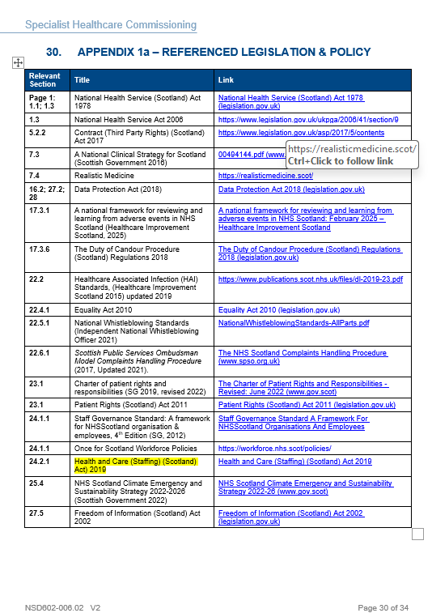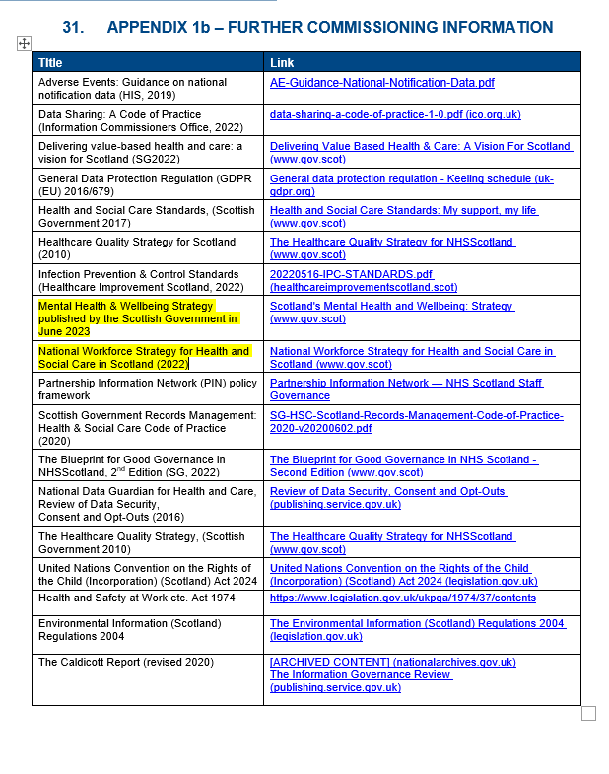

Examples in Practice

Standard clause applied across new and varied agreements; tender/service reviews require workforce tools/benchmarking to justify skill-mix and establishment; contract management reviews track staffing assurances alongside quality and finance.

Evidence & Assurance
NSD commissioning cycle and governance (RAG, dashboards, OMG/SMGC routing) define how changes and concerns are recorded and escalated.

Data points for 2025/26
- Number of new/varied SA contracts that include the HCSA clause: 100%
Breakdown of Service agreements in place:
Scotland health Boards x 8
Private providers (England) x 1
NHS England x 3
- Proportion of tenders requesting explicit workforce-tool evidence: 100%
- SA agreements updated and issued to the HB: 100%
- % signed and returned: 90% (one outstanding and in progress)

Compliance with SA is monitored through ongoing performance management by the commissioning teams and more detailed analysis occurs when any commissioned specialist service undergoes an independent objective review.

SNBTS
SNBTS mainly undertakes work for the Boards rather than Boards undertaking work for the SNBTS. However, NHS Lothian provide SNBTS with a limited amount of laboratory testing (microbiology, Haemoglobin S and total protein) and NHS Highland provide SNBTS with a limited amount of laboratory testing (full blood count and total protein). A small number of NES specialist trainees undertake work for SNBTS and SNBTS contributes to salary costs. All Health Boards in Scotland must comply and report on the Act.

SNBTS have SLAs in place with Health Boards. The SLA with GGC has been updated to include requirements under the Act. The SLAs with other Boards will be updated at review as relevant by the end of FY25/26.

Please provide Information on your methods of monitoring compliance when planning and securing services
This should include details of the local arrangements in place to monitor compliance with the duty, including mechanisms for escalating and addressing areas of non-compliance.

NSD

NSS governance routes ensure quarterly and annual assurance on HCSA duties via Clinical Governance Committee; the Nurse Director reports on compliance and escalations, with SNBTS/NSD reporting aligned.

Evidence & Assurance

Some boards are undertaking organisational wide workforce reviews and because these are in progress, at present, there is no detailed information or evidence from the health boards demonstrating compliance. Boards have indicated that they will be able to provide this in due course.

NSD is responsible for the commission of services but are not involved in patient-facing delivery. Where services are provided within an NHS Board, that Board is responsible for ensuring compliance with the Health and Care (Staffing) (Scotland) Act.

As stated above, we are working with the NHS boards to receive assurance as to their compliance with this legislation as part of ongoing monitoring and review. Completing the workforce planning tools is work in progress at local level requiring familarisation and training to facilitate completion. This work is ongoing, and the current position reflects the most robust assurance available currently.

Data points for 2025/26
Number of annual reports submitted (which are due every May) from services that provide detail on staffing profiles and skill mix. Below is a screenshot (dated 3.3.26) from our performance dashboard which displays return of reports from services as an example of monitoring and oversight in place.

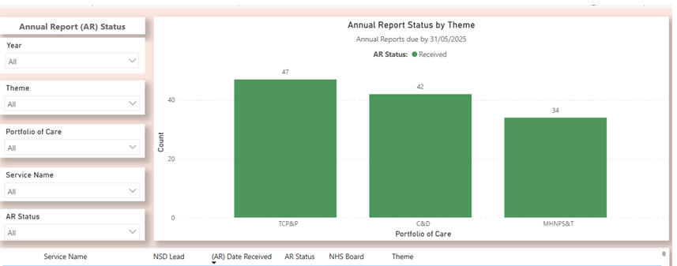

Monitoring:
(1) Commissioning reviews capture staffing assurances, actions, and risks.
(2) Quarterly dashboards triangulate activity, finance, and the quarterly SBAR from the boards will capture staffing related risks.
(3) Contract variations follow the governance route with RAG tracking and formal papers.
(4) Exceptions escalate through Operational Management Group (OMG) and the Strategic Management Group (Clinical) (SMGC) and, where relevant, to Clinical Governance Committee (CGC) and the risk management system

Example in Practice:
Example monitoring flow:
- Detailed workforce analysis and staff requirements outlined as part of any new commissioning process
- Service presents workforce-tool output, more recently as part of a service review
- Concerns on skill-mix or absence trend recorded with actions.
- Persistent risk escalated to Operational Management Group (OMG) and the Strategic Management Group (Clinical) (SMGC) which is the NSD clinical governance meeting
- Review undertaken if review triggers are met
- NSD has provided exception reporting for services at risk with staffing challenges via an extra ordinary National Specialist Services Committee (NSSC)* and also discussed at Strategic Management Group (SMG), Corporate Finance network (CFN); Executive management Team (EMT) and Board Chief Executives (BCE)

*NSSC – National Specialist Services Committee
This is the national committee within NHS National Services Scotland (NSS) that provides clinical governance oversight and assurance for nationally commissioned specialist services, including those overseen by NSD.

Evidence Items:
Slide deck from extra ordinary meetings, action notes from SMG and risk report extracts

Areas of success, achievement, or learning
Area of success / achievement / learning | Details | Further action
This should include details of the NHS function / professional group etc. that the area of success, achievement or learning relates to. | This should describe the situation: what is the success, achievement, or learning?  For example, when procuring from private hospitals, the organisation has incorporated the requirements of the Act into the tender process. | This should describe how the success, achievement or learning could be used in the future.  For example, the learning from tendering with private hospitals is now being used to implement arrangements in other types of procurement.
NSS wide - Guiding principles etc. in health care staffing and planning | NSS process when NSS planning or securing the provision of health care from another Provider that the provider must demonstrate safe and sustainable staffing levels in line with the Health and Care (Staffing) (Scotland) Act) 2019 is described in NHS National Services Scotland Health and Care (Staffing) (Scotland) Act 2019 Guiding Principles and Duties (revised 17/11/2025).
NSD - Consistent safe-staffing clause in NSD contracts.  service reviews explicitly address workforce models (e.g. paediatric/haemato-oncology and adult reviews include staffing profile and CNS requirements). | Examples in Practice  Contract clause usage; workforce model uplift/fix actions agreed with services based on national standards/benchmarking (e.g., CNS profiling, accurate post descriptions).  Evidence & Assurance  - Contract files; review reports; designation/review documentation with workforce sections.  - Roll learning from reviews into commissioning process  Reviews suggest improvements to the performance and outcomes measures of service agreements
SNBTS wide - Guiding principles etc. in health care staffing and planning | SNBTS have SLAs in place with Health Boards. The SLA with GGC has been updated to include requirements under the Act. | The SLAs with other Boards will be updated at review as relevant by the end of FY25/26.

Areas of escalation, challenges, or risks

Area of escalation / Challenge / Risk | Details | Further action
This should include details of the NHS function / professional group etc. that the area of escalation, challenge or risk relates to. | This should describe the situation: what is the challenge or risk identified?  For example, there may have been difficulties in planning or securing services in a speciality area due to a lack of assurance around the appropriateness of staffing arrangements. | This should describe what actions have been / are being / will be taken to address the situation.  For example, engaging with service providers to ensure that they understand what information and assurance is required, seeking alternative service providers etc.
Current themes:  Variation in the quality/formats of provider staffing evidence.  Dependency on external workforce tools and local data completeness. | Evidence & Assurance  SLA tracker.  Oversight Group minutes.  Internal performance Monitoring dashboard / KPIs  CGC reporting line.  Examples in Practice  A develop commissioning guide handbook for all service users -internal and external has been developed  Data points 25/ 26  Number of SLAs updated with HCSA clause vs total: 100%  BCE signed SLAs from each board: 90% (1 outstanding) | Progress assurance of compliance with service providers

COMPLIANCE ASSURANCE LEVEL
Substantial Assurance

