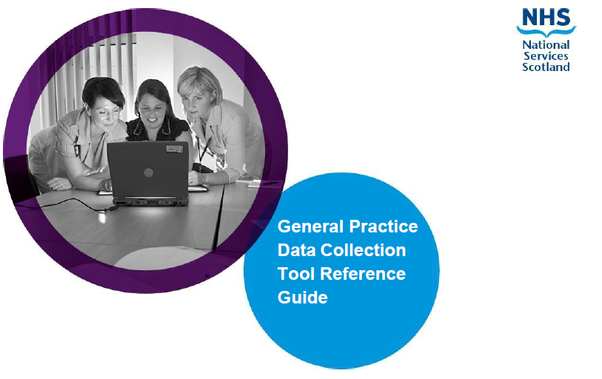

  

## Introduction

The [General Medical Services (GMS) framework document](https://www.gov.scot/Resource/0052/00527530.pdf) clearly sets out the need for robust and reliable data about General Practice.  This collection is focusing on the workforce information at the practice level to allow accurate planning for a resilient and sustainable workforce..

The question set for 2023/2024 has been reviewed in agreement with a short life working group containing representation from BMA, RCGP and Scottish Government.

All GP practices have a contractual obligation to provide the following data to cover a 12 month period:

* **individual staff data** - job roles, contract type, hours/session worked, age and sex
* **workforce data**- Aggregate information on absences (sick leave, maternity/paternity leave, parental leave and special leave), temporary cover and vacancy information for in hours staff employed by the GP Practice

#### Information Governance

The level of personal information collected has been kept to a minimum and is required to process the information for publication and planning purposes. Identifiable information will not be published or shared with the Scottish Government. The information collected will be passed over to NHS Education for Scotland (NES) for analysis and publication. For the purpose of ongoing annual collection and to reduce the burden on practices the information is retained by NSS for re-presenting in future years collections.

Further information on NSS data protection policy can be found here: [Data protection | National Services Scotland (nhs.scot)](https://www.nss.nhs.scot/how-nss-works/data-protection/)

## Helpful Information

Before beginning the questionnaire, below are some of the information you may wish to have to hand to help with completion:

* Contract details for all staff members employed (including partners and GP trainees) between 1 April 2023 and 31 March 2024, including start and leaving date details for all staff members that fall between these dates
* Date of Birth for all staff members
* NMC/GMC numbers
* Sickness and other absence information
* Vacancy information for the time period 1 April 2023 to 31 March 2024
* Details of locum/sessional GP cover

Link to GMC lookup - [The medical register - GMC (gmc-uk.org)](https://www.gmc-uk.org/registration-and-licensing/the-medical-register)

**If you have any difficulties or queries that are not covered in this guidance document, please contact the Project Team at P&CFS:** [**NSS.GPDataCollection@nhs.scot**](mailto:NSS.GPDataCollection@nhs.scot)

## Overview

The GP Workforce Data Collection App contains Guidance Notes, four sections and a Submit button to complete for the year 1 April 2023 to 31 March 2024:

Guidance Notes

1_Practice Information

2_Staff Information

3_Vacancies

4_Absences

5_Submit

You can complete the survey in stages if you wish. You must save your answers before you leave the survey, this will save what you have entered to date and will appear when you go back in.

|  |
| --- |
| Please note that throughout this survey we require Doctor time to be recorded in sessions and non-Doctor time to be recorded in hours. This is relevant across all sections of the survey. For the Survey, a session is 4 hours and 10 minutes. |

## Accessing the App

You will be granted access to the app by the NSS project team, access is based on your M365 account details, if you have provided these to the team you will then be able to access the app for your practice.

There are two ways to access the app, you can use either of these:

1. Through a web browser following this [link](https://apps.powerapps.com/play/e/default-10efe0bd-a030-4bca-809c-b5e6745e499a/a/789c680e-3c77-4da4-9c31-b813b6857d2b?tenantId=10efe0bd-a030-4bca-809c-b5e6745e499a&hint=ba3ef211-3fdf-4543-989c-2de8b9ae2329&source=sharebutton&sourcetime=1715170785969)
2. Through MS Teams, you will need to first search for the app and then add it:
   1. on the left hand banner, click the Apps button at the bottom.

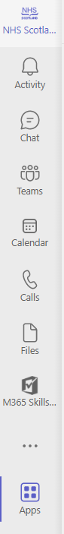

* 1. in the search bar, search for ‘GP Workforce’

* 1. Scroll through the list of Apps that appear until you find the ‘NHS Scotland GP Workforce Survey App 2024’ and click Add

* 1. The App will open in MS Teams, you can navigate back to the App if you move away from it using the 3 ellipses on the bottom of the menu on the left

## Begin the Survey

From the home page, click on the Guidance Notes button

the following screen will appear

From here you will see 6 buttons along the bottom. Click on Practice Information

## Practice Information

Please check the first two boxes to confirm that the Practice information in the top right is correct

**If either or both are incorrect, do not check the relevant box, and email the project team at** [**NSS.GPDataCollection@nhs.scot**](mailto:NSS.GPDataCollection@nhs.scot) **before continuing.**

Please select your Administrative Health Board from the drop down menu.

Please enter the Practice Head Count. This is only for staff directly employed by the Practice and partners.

Vacancies – if you had any vacancies within the Practice in 2023/24 please select Yes from the drop down menu, otherwise select No. Note that these vacancies could have a start date before 1 April 2023.

Temporary Cover – if you select Yes from the drop down menu, a further 3 questions will appear below

Please save your answers



Once you have saved your answers you can move to the next section – Staff Information

## Staff Information

The table is for all staff in post, including partners and trainees throughout the 12 month period, 1 April 2023 to 31 March 2024. You should include every staff member employed in a substantive post, across all staff groups, including partners and any trainees at your practice. You should include those on sabbatical, sick, maternity, paternity, parental, adoption or other leave.

The staff groups covered are Doctor, Non-Doctor Partners, Nurse, Other Direct Patient Care and Admin/Non-clinical.

If you completed the data collection survey last year, the data you submitted will be pre-populated into the relevant columns. Note, as we move to a year round collection, the age field has been replaced with Date of Birth, this is to allow one off data entry, you will need to add Date of Birth for all staff to enable the calculation of age.

Date of Birth – if DOB is not known or if you do not wish to enter this please enter 01/04/2024.

If your Practice did not complete the data collection survey last year, this area will be blank and you will need to enter all information requested.

NB : For this survey we are defining 1 Doctor Session as 4hrs & 10mins

Non Doctor Staff please enter the number of hours that the staff member is contracted for.

If you wish to add new members of staff, please click Start Editing.

Once you click on Start Editing, the screen will change, see below

Click on Add New Row

You will see a row appear at the bottom. Please start completing this row.

If you do not wish to enter staff members names, you can enter Initials only. Staff members names are important for us to identify individuals who may work across other Practices and also help you to identify whose information you enter.

Please be assured that names are confidential and are never published.

Dates for Date of Birth, Start Date and Leave Date can either be selected using the calendar and drop down menus within, or can be typed. Note if typing the format is required to be DD/MM/YYYY.

Move to the right by using the scroll bar. We recommend using your mouse to move the scroll bar across, this keeps the column and headers aligned, and will also freeze the staff members name to the left of the row to allow easy identification.

Note using the TAB button or arrows on your keyboard causes the columns to mis-align with the headers. This is a known issue but cannot be fixed for this collection.



If you wish to enter more members of staff, click on Add New Row again.

Once you have finished entering your data, please click on Save Changes.



You can now move to the next tab, Vacancies.

## Vacancies

If you have answered ‘Yes’ to the Vacancies question on the Practice Information tab, the Vacancies button will appear. If you answered ‘No’ and had no vacant posts during 2023/2024 the button will not appear and you can move directly to the Absences tab.

If your Practice did have vacancies, please click on the button – Start Editing

Select Add New Row and begin completing your data

NB : One Doctor Session equates to 4hrs & 10mins

Non Doctor Staff please enter weekly Hours of the vacant post.

Once you have finished entering your data please press Save Changes

## Absences

Please enter your data. Once you have completed entering your data please click on Save Answers.

Please enter details of the total absences for Doctor and non-Doctor staff groups for the year from 1 April 2023 to 31 March 2024. The absences should be split into total sick leave (including both paid and unpaid), maternity/paternity/adoption leave, parental leave and Special leave. Annual leave and public holidays should not be included.

Doctor absences should be entered in number of sessions.

Non-doctor absences should be entered in hours.

Once you have saved your answers, please now click on Submit.

## Submission

Please check the box to indicate you have completed the survey.

Please click on Finalise & Submit.

On clicking the button, an email will be sent to you containing csv files of your data that you will be able to open in excel should you wish to.

If you wish to update or amend your data, please click on Recall. Update or amend the relevant fields, Save your changes and go back to Submit and click on Finalise & Submit.

## Final Submission

Once all tabs have been completed, please click on Submit by 31st July 2024**:**

Thank you for completing this data collection.