

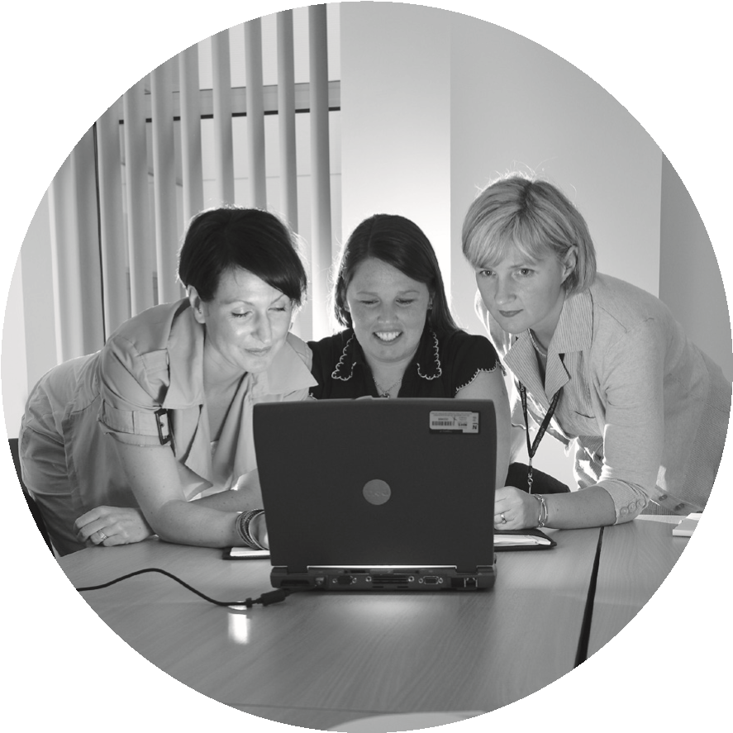

**General Practice**

**Data Collection**

**Staff information leaflet**

**This leaflet is for anyone employed by the GP practice. It explains what you need to know about the General Practice Data Collection and why we are collecting the data.**

**What is the General Practice Data Collection App?**

The General Practice Data Collection App collects information on general practitioners and practice employees including their working patterns, time worked, absences etc.

This information is collected by Practitioner

Services Directorate (PSD), which is part of the NHS in Scotland and looks after a variety of health information for the NHS. PSD is a Directorate of NHS National Services Scotland (NHSNSS). NHSNSS is a public organisation created in Scotland under Section 10 of the National Health Service (Scotland) Act 1978.

**Why is this information being collected?**

PSD has been commissioned by the Primary Care Division of Scottish Government to collect data to support the General Medical

Services (GMS) contract negotiations and Primary Care Workforce Planning.

Providing this information is a contractual obligation for GP practices. This information is being collected to understand the workforce element of a GP practice and the time worked by staff. This will provide data to support ongoing workforce planning.

The information collected will be passed over to NHS Education for Scotland (NES) for analysis and publication.

**What personal information will the General Practice Data Collection hold about me?**

The information collected includes some personal information about you.

* Date of birth and sex.
* Hours/sessions worked.
* Reason for leaving a job.

Names can be recorded to aid data entry by the practice. This information is then removed before data is submitted for analysis and publication.

**Is the information safe?**

Yes. PSD and NES must comply with the law to use your personal information. All information is stored in ways that comply with the General Data Protection Regulation (GDPR) and the Data Protection Act 2018 on computers that can only be accessed with secure passwords and by authorised individuals. PSD and NES staff are bound by data protection legislation and confidentiality rules. Only trained PSD and NES staff with specific security access can see any personal information.

**Who uses the information?**

PSD staff managing the General Practice Data Collection collate and check the information. The information collected will be shared with NES for analysis and publication. Anonymised data may be shared with the Scottish Government and Health Boards to aid workforce planning. Aggregated information on working hours or sessions, demographics and reasons for leaving a job are used as part of the annual GP workforce survey report. The published report will not contain personal information or identify any individuals.

**Your Rights**

Data Protection law gives you rights over how we use your personal details. These and other more detailed information can be found in our Data Protection Notice, available here: [Data protection | National Services Scotland (nhs.scot)](https://www.nss.nhs.scot/how-nss-works/data-protection/)

**Where can I get more information?**

You can contact the GP Data Collection team by emailing: [nss.gpdatacollection@nhs.scot](mailto:nss.gpdatacollection@nhs.scot)

or by writing to:

GP Data Collection

NHS National Services Scotland

Practitioner Services Directorate

Gyle Square

1 South Gyle Crescent

Edinburgh

EH12 9EB

**Accessibility and translations**

If you need this information in another format or a community language, please contact:

Email: NSS.EqualityDiversity@nhs.net

Tel: 0131 275 7457

Text relay: 01800 275 7457

Website: <http://contactscotland-bsl.org/reg/>